SATISH CHANDRA MEMORIAL SCHOOL
PRE MID TERM EXAMINATION (2019-20)
STD – II SUB - MATHEMATICS
NAME : ________________________________ SEC: ________ ROLL:_________
INVIGILATOR’S SIGN ____________________________ DATE : _______________
TIME : [2 hrs] Maximum Marks : 50

- Put a tick ( √) mark for the correct answer - 1x6=6

- One bundle has 10 sticks. How many sticks are there in 6 bundles?
- 6 b) 16 c) 60 d) 10

- 45+25 = ________
- 70 b) 60 c) 75 d) 65

- What is the place value of 2 in 192
- 2 tens b) 2 ones c) 2 hundreds d) 9 ones

- What will be the numeral for two hundred and sixty seven?
- 276 b) 206 c) 267 d) 207

- What comes after 559 ?
- 558 b) 559 c) 506 d) 560

- 8 less than 15 is
- 6 b) 7 c) 8 d) 9

- Fill in the blanks – 1 X 2 = 2

- Write the correct numeral in the box , 2 tens + 3 ones =
- 12 X 6 =

- Do as directed – 2x5 = 10
- Write the numeral in descending order –
HTO HTO H TO HT O
3 2 6 , 360 , 420 , 390

- Write in words
- H T O
346
- H T O
219

- Colour the even numbers pink –
16
5
1
7
13

8
10
12

- Complete by skip counting –
- 84, 86, 88, _____, ______

- 210, 220, 230,______, ______

- Write in expanded form –
- 490 = _________________________________

- 222 = ________________________________

- Solve the following: 2X6=12
TO HTO HTO
61 157 348
-25 + 729 + 483
___ ____ _____
___ ____ _____

HTO HTO TO
783 650 24
-476 - 217 25
_____ _____ + 26
_____ _____ _____
______

E.Solve the word problems: (3x5=15)

- 49 girls and 45boys watched the school drama. How many students watched the school drama?

- A farmer grew 95 tomatoes in his field .During the night , 36 tomatoes were stolen. How many tomatoes were left in his field?

3 .A beehive has 390 honey bees. If 126 honey bees fly out of the hive, how many honey bees are there now?

4.543 bricks were lying in a field, 278 more bricks are put there. How many bricks are there in the field now ?

5.A city has three zoos . The first zoo has 213 animals, the second zoo has 168 animals and the third zoo has 177 animals. How many animals do all the zoos have in total?

F .See and answer - (3)

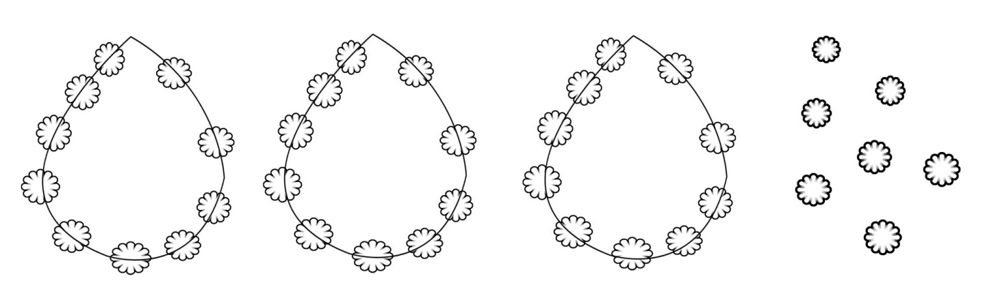

- How many garlands are there? _________________
- How many flowers are there in each garland?_______________
- Count and write the total number of flowers?______________

- How many fish did uncle Sam catch altogether if he had 5 in his bucket and 4 in his net? Circle and write the total number of fish . (2)

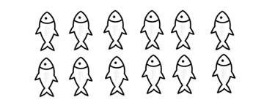

Ans : ________

