SATISH CHANDRA MEMORIAL SCHOOL
METRER SAMPLE QUESTION PAPER 2019
CLASS- VIII
SYLLABUS: REASONING :( 40 marks)
1. ANALOGY
2. CLASSIFICATION
3. SERIES
4. COADING – DECODING
5. BLOOD RELATION
6. DIRECTION SENSE TEST
7. LOGICAL VENN DIAGRAM
8. INSERTING MISSING CHARACTER

CHAPTERS BASED ON ‘NCERT’: (10 marks)
All Chapters from NCERT

SECTION A (REASONING)

Find the wrong number in the series:
- 7, 28, 63, 124, 215, 342, 511
(a) 7 (b) 28 (c) 124 (d) 215 (e) 324
- 46080, 3840, 384, 48, 24, 2, 1
(a) 384 (b) 48 (c) 24 (d) 2
- 5, 10, 40, 80, 320, 550, 2560
(a) 80 (b) 320 (c) 550 (d) 2560
- 10, 26, 74, 218, 654, 1946, 5834
(a) 26 (b) 74 (c) 218 (d) 654
- 445, 221, 109, 46, 25, 11, 4
(a) 25 (b) 46 (c) 109 (d) 221
- DF, GJ, KM, NQ, RT, ?
(a) UW (b) YZ (c) XZ (d) UX (e) YA
- BMX, DNW, FOU, ?
(a) GHO (b) GPS (c) HPS(d) HPT (e) HQS
- A, CD, GHI, ? , UVWXY
(a) LMNO (b) MNO (c) MNOP (d) NOPQ
- D-4, F-6, H-8, J-10, ? ,?
(a) K-12, M-13 (b) L-12, M-1 (c) L-12, N-14 (d K-12, M-14
- __ __ aba __ __ ba __ ab
(a) abbba (b) abbab (c) baabb (d) bbaba
- a __ ba __ b __ b __ a __ b
(a) abaab (b) abbab (c) aabba (d) bbabb
- bca __ b __ aabc __a __caa
(a)acab(b) bcbb (c) cbab (d)ccab
- __ bc __ ca __ aba __ c __ caAA
(a) abcbb (b) bbbcc (c) bacba (d) abbcc
- a __ bd __ da __ dbc __ b __ dc
(a) aabbc(b) bbcca (c) caabb (d)ccbaa
- b__ ccacca __ ba __ bbc __ bc __a
(a)baabc (b abaaa (c) acbca (d)bacab
Directions: There is a certain relation between two given words on one side of :: and one word is given on another side of :: while another word is to be found from the given alternatives, having the samerelation with this word as the given pair has. Select the best alternative.
- Coherent : Consistent :: Irate : ?
(a) Angry (b) Unreasonable (c) Unhappy (d) Irritated
- Tuberculosis : Lungs :: Cataract : ?
(a) Ear (b) Throat (c) Skin (d) Eye
- Physician : Treatment :: Judge : ?
(a) Court (b) Judgement (c) Lawyer (d) Punishment
- Circle : Circumference :: Square : ?
(a) Volume (b) Area (c) Diagonal (d) Perimeter
- Breeze : Cyclone :: Drizzle : ?
(a) Earthquake (b) Storm (c) Flood (d) Downpour
Direction: Three words are given in each question below, which have something in common among themselves. Choose one out of the four given alternatives, which mentions the quality common to the three given words.
- Paradeep :Haldia : Kandla
(a) Industrial centres (b) Ships (c) Port towns (d) Coastal cities
- Kerosene : Petrol : Diesel
(a) Firewood (b) Engine (c) Fuel (d) Coal
- Graphite : Diamond : Coke
(a) Allotropes (b) Abrasives (c) Electrodes (d) Fuels
Directions: In each of the following questions, five words have been given out of which four are alike in some manner, while the fifth one is different. Choose out the odd one.
- (a) Football (b) Volleyball (c) Cricket (d) Chess (e) Hockey
- (a) Violet (b) Blue (c) Green (d) White (e) Yellow
- (a) Tea (b) Cinchona (c) Rubber (d) Cardamom (e) Chalk
- (a) Bajra (b) Mustard (c) Rice (d) Wheat (e) Barley
- In a certain code, DEAF is written as 3587 and FILE is written as 7465. How is IDEAL written in that code ?
(a) 43568 (b) 43586 (c) 63548 (d) 48536 (e) None of these
- In a certain code, EAT is written as 318 and CHAIR is written as 24156. What will TEACHER be written as?
(a) 8312346 (b) 8321436 (c) 8312436 (d) 8313426
- AFDQENI
(a)6728949 (b)€72864€ (c)9728649 (d) 9728949 (e) None of these
- If “light” is called “morning”, “morning” is called “dark”, “dark” is called “night”, “night” is called “sunshine” and “sunshine” is called “dusk”, when do we sleep ?
(a) Night (b) Sunshine (c) Dusk (d) Dark
- If the animals which can walk are called “swimmers”, animals that crawl are called “flying”, those living in water are called “snakes” and those which fly in the sky are called “hunters”, then what will a lizard be called?
(a) Swimmers (b) snakes (c) Flying (d) Hunters (e) None of these
- Rita told Mani, “The girl I met yesterday at the beach was the youngest daughter of the brother-in-law of my friend’s mother.” How is the girl related to Rita’s friend?
(a) Cousin (b) Daughter (c) Niece (d) Friend (e) Aunt
- A man pointing to a photograph says, “The lady in the photograph is my nephew’s maternal grandmother.” How is the lady in the photograph related to the man’s sister who has no other sister?
(a) Cousin (b) Sister-in-low (c) Mother (d) Mother-in-low
Directions: Read the following passage to answer these questions:
Anita, Mahima, rajan, Lata and Deepti are five cousins. Anita is twice as old as Mahima. Rajan is half the age of Mahima. Anita is half the age of Deepti and Rajan is twice the age of Lata.

- Who is the Youngest?
(a) Deepti (b) Ranjan (c) Lata (d) Anita
- Who is the eldest?
- Deepti (b) Lata (c) Anita (d) None of these
- Which of the following pairs of persons are of the same age?
- Mahima and Lata(b) Anita and Mahima(c) Mahima and Rajan(d) None of these
- Anita is younger than
(a) Rajan (b)Mahima (c)Deepti (d) None of these
- If Mahima is 16 years old, then what is the age of Lata?
(a) 4 years (b) 5 years (c) 7 years (d)14 years
Directions: Study the following information and answer the questions given below it :
(i) A weights twice as much as B.
(ii) B weights four and a half times as much as C.
(iii) C weights half as much as D.
(iv) D weights half as much as E.
(v) E weights less than A but more than C.
- Which of the following is the lightest in weighs?
(a) A (b) B (c) C (d) D (e) E
- E is lighter in weight than which of the other two articles?
(a) A,B (b) D, C (c) A,C (d) D,B (e) B,E
- E is heavier than which of the following two articles?
(a) D,B (b) D,C (c) A,C (d) A,B (e) None of these
- Which of the following articles is the heaviest in weight?
(a) A (b) B (c) C (d) D (e) E
- Which of the following represents the descending order of weights of the articles?
(a) A, B, E, D, C (b) B, D, E, A, C (c) E, C, D, A, B
(d) C, A, D, B, E (e) A, B, D, E, C
- Which of the above given statements is not necessary to determine the correct order of articles according to their weights?
(A) (i) (B) (ii) (C) (iii) (D) (iv) (E) (v)
DIRECTIONS: Each one of the following questions consists of three items. Using the relationship between these items, match each question with the most suitable diagram. The letter denoting that diagram is your answer.
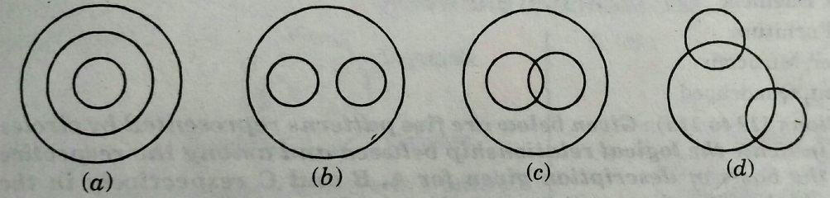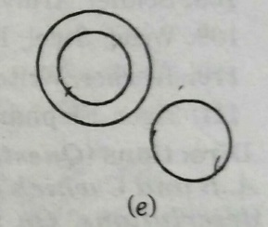
- Plums, tomatoes, Fruits
- Engineer, Doctor, People
- Sea, Island, Mountain
- Elected house, M.M., M.L.A.
- Musicians, Instrumentalists, Violinists
- Grams, Beans, Legumes
- Mountains, Forests, Earth
- Biology, Botany, Zoology
- Factory, Machinery, Product
- Truck, Ship, Goods
Find the missing number in the series:
- 1,2,3,1,4,9,1,...27
A) 5 B) 4 C)16 D)8
- 3,5, 9,17,33....
A) 44 B) 65 C)64 D)49
- 6,5,24,25,144,(?)
A) 155 B) 160 C)170 D)175
- 128,64,32...?
A) 33 B) 35 C)38 D)16
- 8, 20, 36, 56,.....
A)80 B) 100 C)64 D)84
- 1, 8, 4, 27, 9, ?
A)8 B) 9 C)64 D)16
- What is −|5−12|−|5−12| ?
A)-17 B) 7 C)17 D)-7
- Rohit is 40 m South-West of Aarav. Ansh is 40 m South-East of Aarav. Then Ansh is in which direction of Rohit?
- East (B) West (C) North-east (D) South
- Find out the wrong term in the given series. 24, 27, 31, 33, 36
A)24 B) 27 C)31 D)33
- 200 kg of sugar was purchased at the rate of ` 15 per kg and sold at a profit of 5%. Compute the selling price per kg.
- Rs 18.25 (B) Rs 13.85 (C) Rs 15.75 (D) Rs 31.50
- Which property is used in the equation given below? 12(x + 4) = 12x + 48
- Associative Property of Addition (B) Commutative Property of Addition (C) Distributive Property (D) Reflexive Property
- Three numbers are in the ratio 2 : 3 : 4. The sum of their cubes is 33957. Find the largest number.
- 28 (B) 21 (C) 32 (D) 14
- Mohit is thinking of two numbers. Their greatest common factor is 6. Their least common multiple is 36. One of the numbers is 12. What is the other number?
- 18 (B) 16 (C) 6 (D) 24
- Ramu put a square fence around his vegetable garden to keep the deer away from eating his corn. One side was 10 m in length. If the posts were placed 2 m apart, how many posts did he use?
- 16 (B) 20 (C) 10 (D) 15
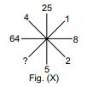
- . Find the number of coins, each of which are 1.5 cm in diameter and 0.2 cm thick, required to form a right circular cylinder of height 10 cm and diameter 4.5 cm.
- 450 (B) 250 (C) 350 (D) 400
- Which number will replace the (?) in Fig. (X)?
- 1 (B) 2 (C) 3 (D) 4
- A rectangular prism has a length of 14 cm, a height of 8 cm, and a width of 3 cm. What is the volume?
- 25 cu cm (B) 42 cu cm (C) 112 cu cm (D) 336 cu cm
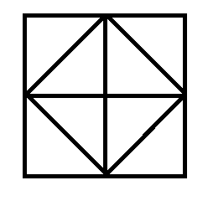
- Which of the following options most closely resembles the mirror image of the given word, if the mirror is placed vertically to the left? STROKE
- S T R O KE (B) EKORTS (C) ROKETS (D) S
- Count the number of triangles in the given figure.
- 8 (B) 10 (C) 12 (D) 14
- Mohit gains 60 paise on ` 60. His gain percent is ________.
- 1% (B) 0.1% (C) 2% (D) 1.1%
- In a parking lot, 1 out of every 8 cars is blue. What percent of the cars in this lot are blue?
- 1.25% (B) 7% (C) 9% (D) 12.5%
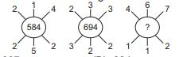
- . A duck flew at speed of 18 km per hour for 3 hours, then at speed of 15 km per hour for 2 hours. How far did the duck fly in all?
- 69 km (B) 75 km (C) 81 km (D) 84 km
- Find the missing number, if the same rule is followed in all the three figures.
- 937 (B) 824 (C) 769 (D) 678
- Complete the pattern. 6, 11, 21, 36, 56, (...?...)
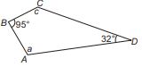
- 42 (B) 51 (C) 81 (D) 91
- For the quadrilateral shown here, what is the value of ∠a + ∠c?
- 53° (B) 137° (C) 180° (D) 233°
- An express train from Dallas to San Francisco runs every 5th day. If train went on Tuesday, after how many days will train go on a Friday?
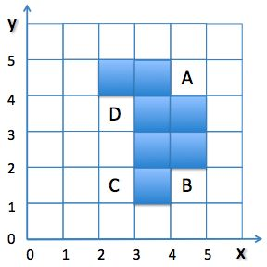
a) 7 days b) 4days c) 10 days d) 12 days
- Add one square to this pattern to give it one line of symmetry. Find the position of the square.
- C b) B c)A d)D
- Daniel is the brother of the son of Ronald's son. How is Daniel related to Ronald?
a) Cousin b) Grandson c) Uncle d) Brother
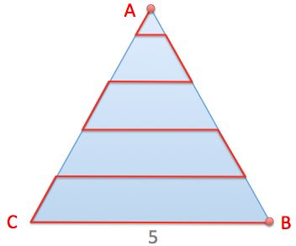
- An ant goes from A to B along the indicated path in the equilateral triangle with sides that have a length of 5. The distance between the horizontal lines is the same as the distance between point A and the first line. The horizontal pathways are parallel to BC.
How long is the entire path?
a) 22 b) 20 c) 18 d) 15
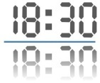
- I place a digital clock on a mirror.
The time 18:30 on the clock reads the same when it is reflected in the mirror.
What other time has the same property?
- 08:13 b) 05:55 c)18:19 d) none of these
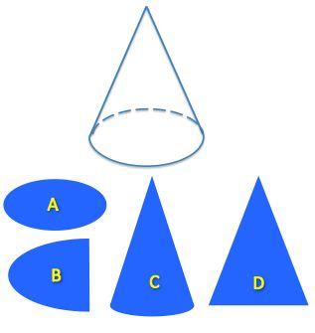

- Which shape could NOT be a cross section of a cone?
- C b)A c) B d) D
- Four matchsticks form a square. How many non-overlapping squares can be formed using seven matchsticks?
- 6 b) 5 c) 2 d) 3
- Egyptian pyramids are square pyramids. Which of the following nets can be folded to form a square pyramid?
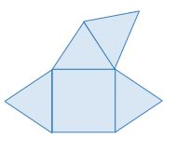
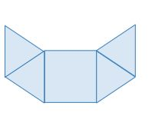
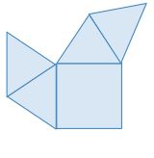
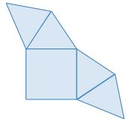
- b) c) d)

- How many lines of symmetry does a circle contain?
a)one b) two c) an infinite number d) six

- Men: Women = 5:3, Women: Children= 2:5. Then Men: Women: Children = ?
A. 10:6:15 B. 10:9:13 C. 15:10:3 D. none of these
Directions: ( Question 91 to 95) : In the following questions, answers are to be based on the diagram given below,where the triangle represents doctors, the circle represents players and the rectangle represents artists.
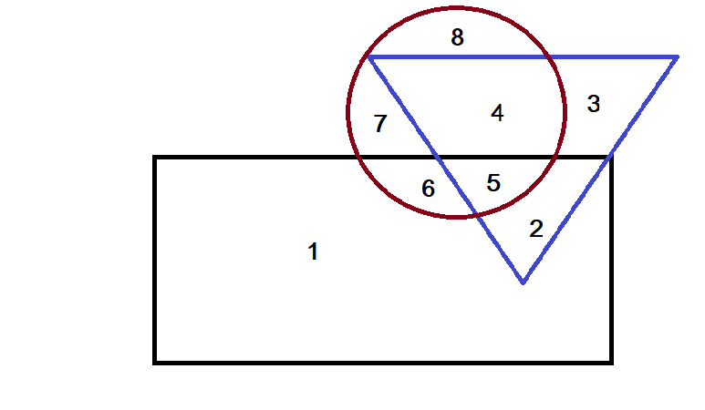

- Which number space in the diagram represents doctors who are also players and artists?
- 2 b)3 c)4 d)5
- Which number represents artists who are also players only?
- 4 b)6 c)7 d)8
- Which number represents artists who are neither players nor doctors?
- 1 b)2 c)3 d)4
- Which number represents doctors who are neither players nor artists?
- 2 b)3 c)4 d)5
- Which number represents players who are neither artists nor doctors?
a)1,2 b)3,4 c)6,7 d)7,8
Directions: ( Question 96 to 99) : Choose the Venn diagram which best illustrates the three given classes in each questions)
- Window, Room , Wall
- A b)B c)C d)D
- State, Country, City
a)A b)B c)C d)D
- Copper, Paper, Pire
a)A b)B c)C d)D
- Teacher, Graduate, Player
a)A b)B c)C d)D
- What is the name of 11 sided polygon:
a)Hendecagon b)Dodecagon c)Hexagon d)None of these

SECTION B (NCERT)
- Which of the following is not irrational?
- 6X2 b)6÷2 c) 6-2 d)6+2

- Linear equation in one variable is an equation with only one variable and
- Degree 2 b) degree 2 c) no degree d) degree 3.
- If a+12=20, b+6=26, C÷3=4, and 8Xd=96, then the value of X when a+b+c+d+x=58 is
- 6 b) 8 c)7 d)9
- If $\frac{2-8x }{16+5x }$ = 0 then 4x =? a) 2 b) 3 c) 1 d) 5
- If $\sqrt{\frac{32.4}{x}}=2$ then x=? a)8.1 b) 4 c) 4.1 d) 8
- 28$\sqrt{x}+1426=\frac{3 }{4 } of 2872$ then x=? a)576 b) 676 c)1296 d)1444
- The square root of ${272}^{2 }-{128}^{2}$is a) 144 b) 200 c) 240 d) 256
- $\sqrt{41- \sqrt{21+\sqrt{19-√9}}}=$? a) 4 b) 26 c) 16 d) 6
- $\sqrt[3]{1105529}=?$
- 72 b)62 c)42 d)48
- A rational number equivalent to 5/7 is:
- 15/17 b) 25/27 c) 10/14 d) 14/10
- Which one is irrational number : a) 12 b) $√13$ c)$\sqrt{64}$ d)none of these

- Supplement of 10$°$ is : a)90$°$ b) 170$°$ c) 80$°$ d) 360$°$
- The cube root of 0.004913 is:
- 0.19 b)01.7 c)0.017 d)0.019

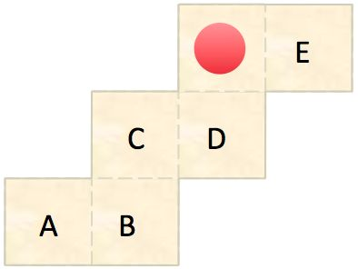

- A net can be folded into a cube. Which of the faces is opposite the face marked red?
- D b)B c) A d) C
- The ratio of the areas of the inscribed circle to the circumscribed circle of an equilateral triangle is a) 2:8 b)1:4 c)4:1 d)8:2
- If ${(\frac{3}{5})}^{th}$of a cistern is filled in 30 minutes, then rest will be filled in 12+a minutes, then a= ?
- 8 b)5 c)16 d)4
- If $a^{3}+b^{3}:a^{3}-b^{3}=133:117$ then a: b=?
- 2:3 b)5:4 c) 5:2 d)10:2
- In a bag, there are coins of 25p, 10p and 5p in the ratio 1:2:3. If there is Rs 30 in all, how many 5p coins are there? a) 50 b)100 c)150 d)200
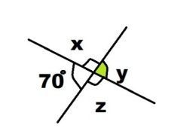

- Find the value of x is ____? a) 180$°$ b) 110$°$ c)70$°$ d)None of these
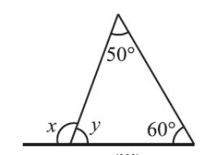

- From the following figures find the value of x
a) 110$°$ b) 60$°$ c) 180$°$ d) None of these

Question No. | Answer |  | Question No. | Answer
61 | c |  | 91 | d
62 | d |  | 92 | b
63 | a |  | 93 | a
64 | c |  | 94 | b
65 | c |  | 95 | d
66 | c |  | 96 | B
67 | a |  | 97 | A
68 | a |  | 98 | D
69 | d |  | 99 | C
70 | a |  | 100 | a
71 | a |  | 101 | c
72 | d |  | 102 | b
73 | d |  | 103 | a
74 | c |  | 104 | c
75 | a |  | 105 | a
76 | d |  | 106 | b
77 | d |  | 107 | c
78 | d |  | 108 | d
79 | c |  | 109 | d
80 | d |  | 110 | c
81 | c |  | 111 | b
82 | a |  | 112 | b
83 | b |  | 113 | b
84 | b |  | 114 | b
85 | a |  | 115 | c
86 | a |  | 116 | a
87 | a |  | 117 | c
88 | b |  | 118 | c
89 | c |  | 119 | b
90 | a |  | 120 | a

Sample question of Metrer 2nd level , 2018
Class VIII

1.If DELHI is coded as 73541 and CULCUTTA as 82589662, how can CALICUT be coded? Ans: 8251896.
2. In a certain code, DESK is written as #$52, RIDE is written as %7#$. How is RISK written in that code ? Ans: %752.
3. In a certain code If SPIDER is written as PSDIER, how would COMMON be written in that code ? Ans: OCMMNO .
Write the correct alternative:
4. 3,7,15,?,63,127 Ans: 31
5, M,N,O,L,R,I,V,? Ans: E.
6.UPI,?,ODP,MBQ,IAW Ans: SHJ.
7. Of the 5 villages P,Q,R,S and T situated close to each other,P is to the west of Q, R is to the south of P ,and t is to the north of Q and S is to the east of T. Then, R is in which direction with respect to S? Ans: South west.
8. P’s father Q is B’s paternal uncle and A’s husband M is P’s paternal uncle. How is A reteted to B?Ans : Mother.
9. Ploting towards a boy, “Veena said, He is the son of only son of my grandfather.” How is that boy related to Veena? Ans : Brother.
10. If kamal says , Ravi’s mother is the only daughter of my mother”, how is kamal related to ravi ? Ans: maternal uncle.
11. Going 50m to the south of her house, Radhika turns left and goes another 20m. Then, turning to the north, she goes 30m and then start walking to her house. In which direction is she walking now? Ans: North west .
12. If south east becomes north, north east becomes west and so on , what will west become? Ans: south east.
13. In a coding system, SHEEP is written as GAXXR and BLEAT as HPXTN. How can SLATE be written in this coding system? Ans : GPTNX.
14. Find out the wrong term:
196,169,144,121,101. Ans : 101.
15 . Ludhiana : Hosiery : : Surat : ? Ans : Textile.
16. If HEALTH is written as GSKZDG, then how will NORTH be written in that code ? Ans : GSQNM
17. IF in a certain language, POPULAR is coded as QPQVMBS, which word would be coded as GBNPVT ? Ans : FAMOUS
18. Pointing towards Rita, Nikhil said, “I am the only son of her mother’s son”. How is Rita related to Nikhil?Ans : Aunt
19. A and B are brothers. C and D are sisters. A’s son is D’s brother. How is B related to C ? Ans : Uncle
20. I am facing east. I turn 100$°$ in the clockwise direction and then 145$°$ in the anti-clockwise direction. Which direction am I facing now? Ans : North-east
21. Answer the question mark so that a series is formed by the following figures A,B,C,D,E taken in order.
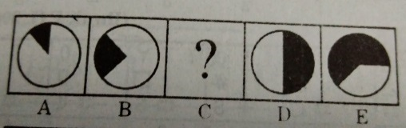
Ans : 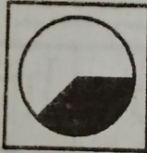
22.Answer the question mark so that a series is formed by the following figures A,B,C,D taken in order.
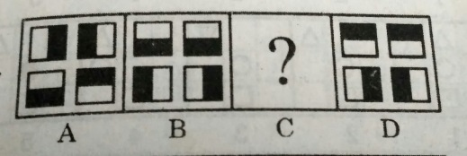
Ans : 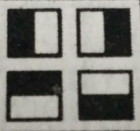
23. Some of the cricket players are tennis players, some tennis players are hockey players, no cricket player is a hockey player.
Draw a venn diagram.
Ans. 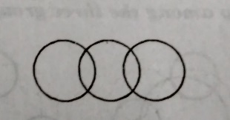
24.A,B,C and D are playing cards. A and B are partners. D faces towards North. If A faces towards West, then who faces towards South ? Ans : C
25. Study the diagram below and identify the region representing youth who are employed but not educated.
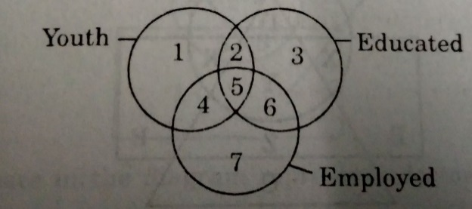
Ans: 4 only

Group B
1.If 5% is expressed as a ratio, then the answer is
Ans: 1:20
2. If s.p of a television is Rs.14400 and loss Rs. 2400 on it, then his loss% is Ans: 14.28.
3.If M.P Rs. 54, discount Rs.6 then S.P = ? Ans : 48
4. If increase 80 by 20%, then the result is
Ans: composite number, divisible by 3.
5.The perimeter of a rectangle is 34m. If the length is 2m more than twice the width, then the width of the rectangle is ..
Ans. 5 m
6. The average of 35,45,x is equal to five more than twice x, then x is
Ans: 13
7. Find a number, twice of which decreased by 7 gives 65
Ans :36
8. The perfect square number between 50 and 60 is
Ans : No number.
9. 28$\sqrt{x}$ +1426=3/4 of 2872, then the value of x is
Ans : 676
10. The least number by which 200 must be multiplied to make it a perfect square Ans: 2
11. A sum of Rs. 30000 is given for interest for 3 years at 7.5% p.a. at the compound interest. What is the sum at the end of the 2nd year? Ans :Rs.34,668.75
12. What is the number which when increased by 15% becomes 414 ? Ans: 360

