Answer the following Multiple-Choice Questions: -
1. __________ is the collection of facts and figures.
a. Data b. Information c. Software d. Hardware
2. Organized and processed data is known as –
a. Data b. Information c. Graph d. Document
3. A byte is made up of –
a. 16 bit b. 4 bit c. 8 bit d. 1024 bit
4. A computer always stores data as __ s and ___ s.
a. 1; 2 b. 1; 0 c. 1; 10 d. 0; 10
5. 1 Gigabyte is equal to –
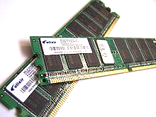
a. 1024 KB b. 1024 TB c. 1024 MB d. None
6.

Name of these objects are?
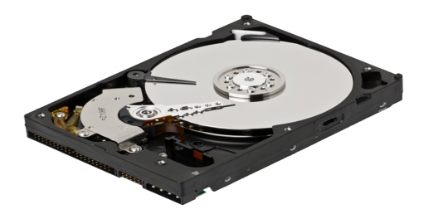
a. ROM b. Hard Disk c. RAM d. Pen Drive
7.

What is this known as?

a. Hard Disk b. ROM c. Pen Drive d. Platter
8.
What is this object called?
a. DVD b. Blu-Ray c. CD d. Pen Drive
9. It is a primary memory-
a. Hard Disk b. PROM c. Pen Drive d. Memory Card
10. It is used in Camera, Smart Phone –
a. Memory Card b. Blu-ray c. DVD d. CD

