Satish Chandra Memorial School
Case Study
CLASS 09 - SOCIAL SCIENCE
Time Allowed : 10 mins Maximum Marks : 86
 | Section A
1 | Which one amongst the following rivers flows through a rift valley?  a) Tungabhadra  b) Krishna  c) Tapi  d) Mahanadi | [1]
2 | Wular lake is located in:  a) Odisha  b) Kerala  c) Jammu & Kashmir  d) Meghalaya | [1]
3 | Which one of the following lakes is a salt water lake?  a) Wular  b) Sambhar  c) Gobind Sagar  d) Dal | [1]
4 | Which of the following river form braided channels?  a) Godavari  b) Brahmaputra  c) Krishna  d) Narmada | [1]
5 | Ambala is located on the water divide between:  a) The Ganga and Brahmaputra river systems  b) The Indus and The Ganga river systems  c) the Indus andBrahmaputra river systems  d) The Indus and Brahmaputra riversystems | [1]
6 | Which one of the following is the longest river of the Peninsular India?  a) Narmada  b) Godavari  c) Krishna  d) Mahanadi | [1]
7 | Dhuandhar Falls is located in:  a) Punjab  b) Uttar Pradesh  c) Odisha  d) Madhya Pradesh | [1]
8 | Loktak lake is situated in:  a) Tripura  b) Manipur  c) Arunachal Pradesh  d) Meghalaya | [1]
9 | Which of the following is the largest salt water lake in India?  a) Chilika lake  b) Lonar crater lake  c) Pulicat lake  d) Pangong lake | [1]
10 | The Brahmaputra enters India in the state of:  a) Arunachal Pradesh  b) Manipur  c) Sikkim  d) Assam | [1]
11 | Which of the following is the largest of all the west - flowing rivers of the Peninsula?  a) Narmada  b) Luni  c) Mahi  d) Sabarmati | [1]
12 | At what place do the Ganga and Yamuna rivers have their confluence?  a) Haridwar  b) Allahabad  c) Dehradun  d) Kolkata | [1]
13 | Which of the following river is the longest in India?  a) Brahmaputra  b) Ganga  c) Indus  d) Tapi | [1]
14 | In which of the following places do the Bhagirathi and Alaknanda rivers join?  a) Brahmagiri  b) Devaprayag  c) Sanguan  d) Rishikesh | [1]
15 | In which of the following states is the Wular lake located?  a) Jammu and Kashmir  b) Punjab  c) Rajasthan  d) Uttar Pradesh | [1]
16 | The river Narmada has its source at:  a) Slopes of the Western Ghats  b) Brahmagiri  c) Amarkantak  d) Satpura | [1]
17 | Awinding curve or bend in a river is known as:  a) Delta  b) Meander  c) Braided stream  d) Cut - offs | [1]
18 | Which of the following rivers make estuaries?  a) The Indus  b) The Brahamputra  c) Narmada  d) The Ganga | [1]
19 | Which of the followingis the river island of Brahmaputra?  a) Majuli  b) Kabirvad  c) Bhavani island  d) Quibble island | [1]
20 | The Brahmaputra is known as the Tsang Po in:  a) Nepal  b) India  c) China  d) Tibet | [1]
21 | Match the following: 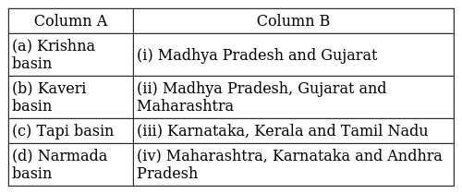 | [1]
22 | Match the following: 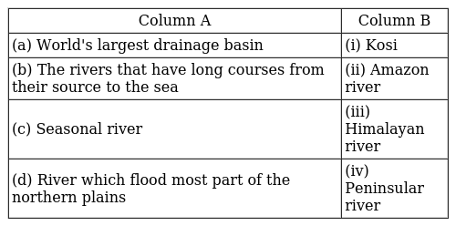 | [1]
23 | Match the following: 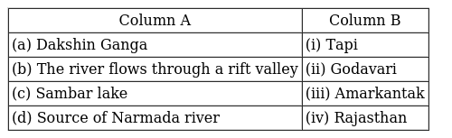 | [1]
24 | Match the following: 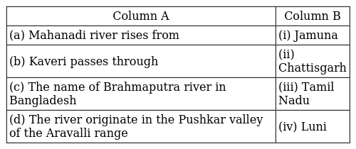 | [1]
25 | Match the following: 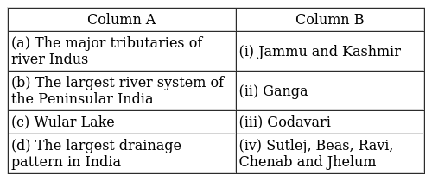 | [1]
26 | Match the following: 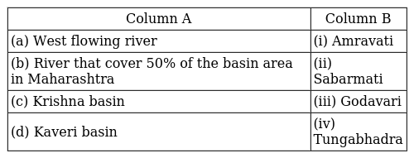 | [1]
27 | Match the following: 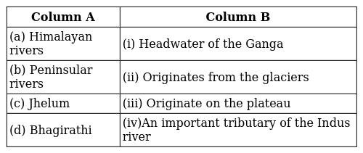 | [1]
28 | Match the following: 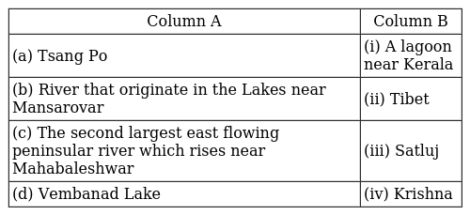 | [1]
29 | Match the following: 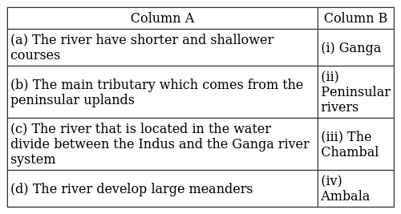 | [1]
30 | Match the following: 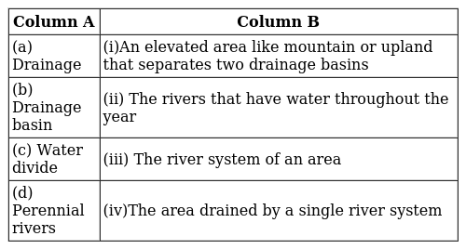 | [1]
31 | Write a short note on Sunderban Delta. | [2]
32 | How Indian lakes differ from each other? | [2]
33 | Write a brief account on the Indus Water Treaty. | [2]
34 | How do rapid urbanisation and industrialization cause river pollution? | [2]
35 | Discuss the significant difference between the Himalayan and the Peninsular rivers. | [2]
36 | From where does the river Brahmaputra originate and name the tributaries of Brahmaputra River. | [2]
37 | Write a short note on Mahanadi basin. | [2]
38 | Write a short note on Kaveri basin. | [2]
39 | What are Man - made lakes? | [2]
40 | Why are most of the Peninsular riversdraining into the Bay of Bengal? Give tworeasons. Name two rivers draining into the Arabian Sea. | [2]
41 | Write a short note on Delta. | [2]
42 | Write down the features of the East Flowing Rivers. | [2]
43 | Describe any three features of the Himalayan rivers. | [2]
44 | Give characteristics of the Ganga - Brahmaputra River System. | [2]
45 | Write a short note on Krishna basin. | [2]
46 | Write down the features of the West Flowing Rivers. | [2]
47 | - How are most of the fresh water lakes in the Himalayan region formed?Giveexamples of fresh water lakes of this region.  - How is Sambhar lake useful? | [2]
48 | State some economic benefits of rivers and lakes. | [2]
49 | Explain Water Divide with an example. | [2]
50 | From where does the Ganga originate and name the tributaries of Ganga River. | [2]
51 | Read the following text carefully and answer the questions that follow:  The river Indus rises in Tibet, near Lake Mansarowar. Flowing west, it enters India in the Ladakh district of Jammu and Kashmir. It forms a picturesque gorge in this part. Several tributaries, the Zaskar, the Nubra, the Shyok and the Hunza, join it in the Kashmir region. The Indus flows through Baltistan and Gilgit and emerges from the mountains at Attock. The Satluj, the Beas, the Ravi, the Chenab and the Jhelum join together to enter the Indus near Mithankot in Pakistan. Beyond this, the Indus flows southwards eventually reaching the Arabian Sea, east of Karachi. The Indus plain has a very gentle slope. With a total length of 2900 km, the Indus is one of the longest rivers of the world. A little over a third of the Indus basin is located in India in the states of Jammu and Kashmir, Himachal Pradesh and the Punjab and the rest is in Pakistan.  - To which direction does the river Indus flow before reaching the Arabian Sea? (1)  - Mention the Indian states covered by the Indus River basin. (1)  - Which rivers join the Indus in Pakistan? (2) | [4]
52 | Read the following text carefully and answer the questions that follow:  The headwaters of the Ganga, called the ’Bhagirathi’ is fed by the Gangotri Glacier and joined by the Alaknanda at Devaprayag in Uttarakhand. At Haridwar the Ganga emerges from the mountains on to the plains. The Ganga is joined by many tributaries horn the Himalayas, a few of them being major rivers such as the Yamuna, the Ghaghara, the Gandak and the Kosi. The river Yamuna rises fromthe Yamunotri Glacier in the Himalayas. It flows parallel to the Ganga and as a right bank tributary, meets the Ganga at Allahabad. The Ghaghara, the Gandak and the Kosi rise in the Nepal Himalaya. They are the rivers, which flood parts of the northern plains every year, causing widespread damage to life and property but enriching the soil for the extensive agricultural lands. The main tributaries, which come from the peninsular uplands, are the Chambal, the Betwa and the Son. These rise from semi - arid areas, have shorter courses and do not carry much water in them. Enlarged with the waters from its right and left bank tributaries, the Ganga flows eastwards till Farakka in West Bengal. This is the northernmost point of the Ganga delta. The river bifurcates here; the Bhagirathi - Hooghly (a distributary) flows southwards through the deltaic plains to the Bay of Bengal. The mainstream, flows southwards into Bangladesh and is joined by the Brahmaputra. Further downstream, it is known as the Meghna. This mighty river, with waters from the Ganga, and the Brahmaputra, flows into the Bay of Bengal. The delta formed by these rivers is known as the Sunder ban delta.  - Where does River Ganga touch the plains descending from the mountains? (1)  - Which river runs parallel to the Ganga before becoming its tributary? (1)  - Mention any two features of the Ganga Delta. (2) | [4]
53 | Two features A and B are marked in the given political map of India. Identify these features with the help of the following information and write their correct names on the lines marked on the map.  - A west flowing river  - A river on which the world’s highest gravity dam is built  - On the same political map locate and label the following  - Chilka lake  - 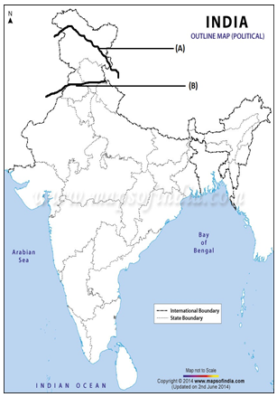 | [2]
54 | Two features A and B are marked in the given political map of India. Identify these features with the help of the following information and write their correct names on the lines marked on the map.  - A River  - A River  - On the same political map locate and label the following  - Krishna River  - 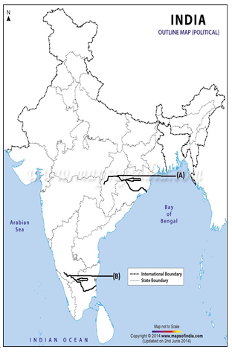 | [2]
55 | Two features A and B are marked in the given political map of India. Identify these features with the help of the following information and write their correct names on the lines marked on the map.  - A Salt Water Lake  - A river which form an estuary  - On the same political map locate and label the following  - Walur lake  - 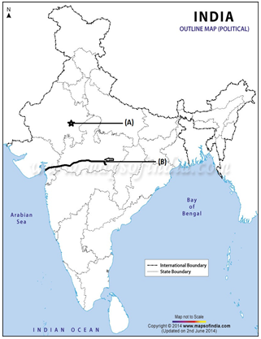 | [2]
56 | Two features A and B are marked in the given political map of India. Identify these features with the help of the following information and write their correct names on the lines marked on the map.  - A Dam  - A Dam  - On the same political map locate and label the following  - Pulicat lake  - 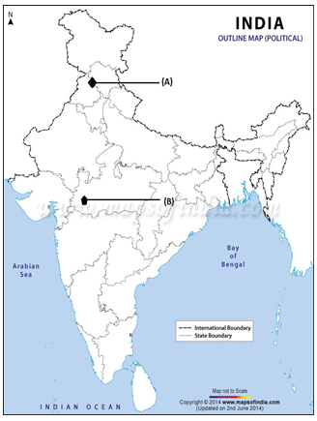 | [2]

