Seeds and seeds
Q1. Explain the process of germination of seeds with a labelled diagram
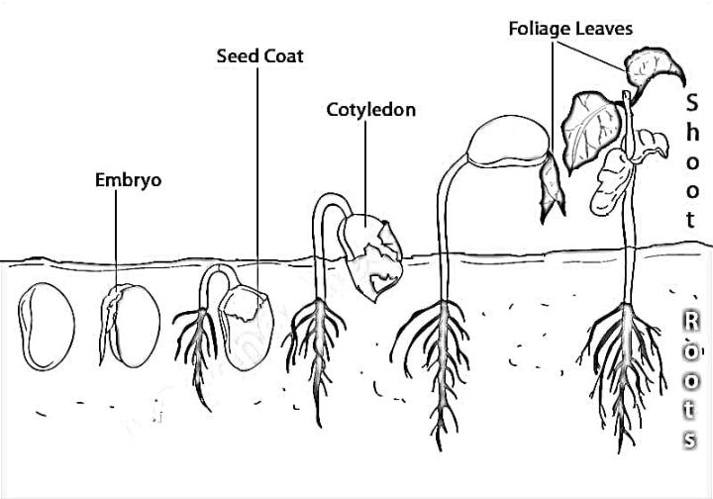
- Seed coat: The outer protective covering of the seed.
- Embryo: The baby plant inside the seed is called Embryo.
- Root: The part of the plant that grows downwards into the soil and absorbs water and nutrients.
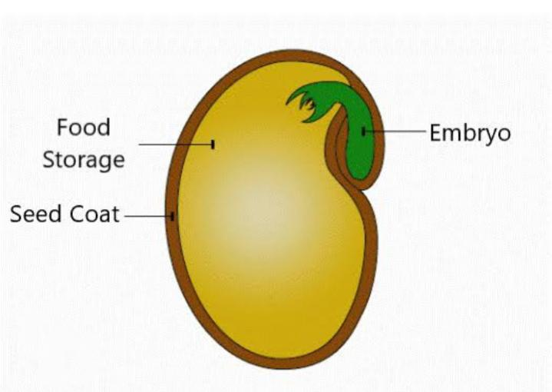
- Shoot: The part of the plant that grows upwards, containing the stem and leaves.
- Cotyledons: These are seed leaves that store food for the young plant.

Germination is the process by which a seed grows into a seedling. It needs air, water and sunlight to germinate. A seed needs oxygen from the air to breathe. Water softens the seed coat. On getting the right conditions, the embryo becomes active and grows into tiny roots and shoot.

Q2. Mention the 2 major types of seed.
Ans-
Two types of seeds are-
- Monocotyledon- It comprises of a single embryonic leaf . Wheat, coconut, garlic, and ginger are the examples of monocotyledons. Monocotyledons are also known as monocots.
- Dicotyledon- It comprises of two embryonic leaves. Almonds, cashews, tomatoes, and peas are the best examples of dicotyledon seeds. Dicotyledons are also known as dicots.

Q3. Raghu’s observed that Plants of same kind do not grow at a specific place close to each other. Why?
Ans- If plants grow too close to each other, they will not get sufficient, space, air, water and sunlight for their growth. Therefore, the seeds need to be scattered far away from each other. This scattering of seeds is called seed dispersal.
Seeds are dispersed by wind, water, animals or by the explosion by fruit. These are called agents of dispersal.

  - Dispersal by wind- Seeds of some plants are small and light which can be carried away by wind easily. Example- seeds of cotton, dandelion, Hiptage, maple and sycamore.
  - Dispersal by water- Flowing water carries away fruits or seeds. Examples- Coconut, Lotus, Lillie
  - Dispersal by explosion- When the fruits of some plants get dry, they burst open and the seeds drop on the ground.
Examples- Pea, Beans, Lady's finger
Dispersal by animals- Fruits of some plants have hooks, spines or stiff hair which stick to the fur of animals or clothes of human.
Test your knowledge:
Q4. Give a brief description of the pitcher plant in your own words with the help of diagram.
Ans by own
Q5.What is a Velcro.Who invented it?
______________________________________________________
(vii) What are the various uses of Velcro?

