EVS class test. Date 10/7/25
FM :10
MCQ. (1x4=4)
- Renewable resources are recycled and reused.An example is-
  - Coal b. Water
c.kerosrne d.natural gas
2.Tunnels are made in the railway route for-
a. Crossing cities and villages easily.
b. Making the journey longer.
c. Making the journey risky.
d. Crossing the mountains and hills easily.
3.Statement:The railway tracks crosses
the roads only at level crossing.
Reason: A level crossing is very important
for the safety of people and vehicles.
- Statement is correct but reason is not justified.
- Statement is incorrect but reason is justified.
- Both statement and reasons are justifying each other.
- Statement and reason are not justified.
4.The sign which we do not observe at
a level crossing:
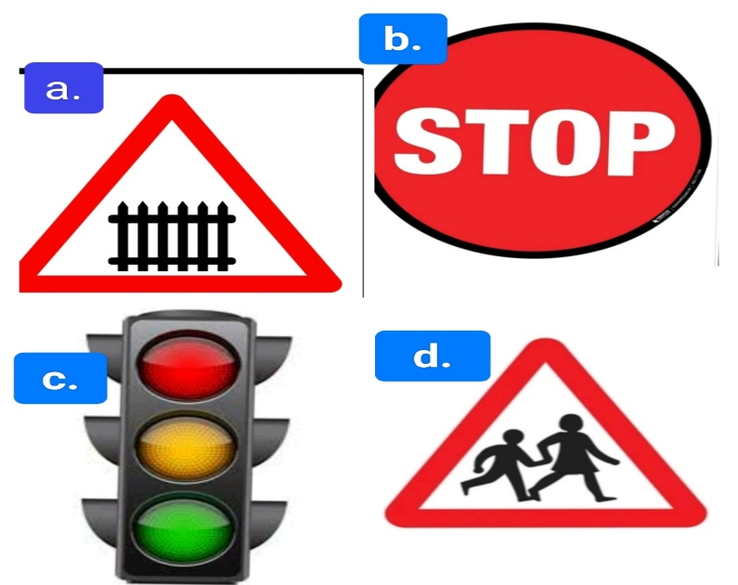

Questions and answers:
5.Mention two ways by which we can
reduce the consumption/usage of petrol.(2)
6.Define fossil fuels. Give 2 examples. (2)
7.Name the things that you can observe in both
the pictures and mention 2 differences between them.(2)
