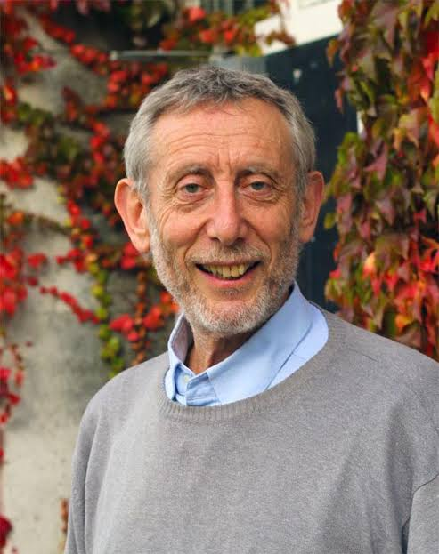

Michael Wayne Rosen (born 7 May 1946) is an English children's author, poet, presenter, political columnist, broadcaster, activist, and academic, who is a professor of children's literature in the Department of Educational Studies at Goldsmiths, University of London. He has written over 200 books for children and adults. Select books include We're Going on a Bear Hunt (1989) and Sad Book (2004). He served as Children's Laureate from June 2007 to June 2009. He won the 2023 PEN Pinter Prize, awarded by English PEN, for his "fearless" body of work.

Summary of the Poem – Chivvy by Michael Rosen

The poem Chivvy presents a humorous and realistic portrayal of the constant nagging or instructions that adults give to children. The poet, Michael Rosen, lists several typical commands often heard from grown-ups, such as “Speak up,” “Don’t talk with your mouth full,” “Say thank you,” and “Pull your socks up. “These statements reflect how adults expect children to behave “properly” all the time. However, these instructions often feel overwhelming and contradictory. For example, children are told to speak up but also told not to interrupt. They are asked questions but then told not to be funny or expressive.
By the end of the poem, the poet cleverly criticizes the irony of adult behaviour—while adults constantly control and instruct children, they suddenly expect them to become independent and make their own decisions without prior freedom or trust.
The poem effectively captures the frustration and confusion a child experiences due to the excessive rules imposed by adults.
ANALYSIS
The poem Chivvy is a funny but meaningful poem. It shows how grown-ups keep giving orders to children all the time. The word chivvy means to keep nagging or telling someone what to do again and again. The poet, Michael Rosen, wants us to think about how this affects children. When adults always correct children, the children feel they are not trusted. Adults want them to behave properly but don’t give them a chance to think or decide for themselves. The poem ends by pointing out how unfair it is that after all this, adults expect children to suddenly become responsible and make their own choices. The poem tells us that instead of only giving instructions, adults should give children more freedom, trust, and a chance to learn from their own experiences. The poet wants adults to understand children better. Instead of always correcting them, they should help children grow by guiding them gently and trusting them more.

