MATERIALS AROUND US
- Assertion -Reasoning:
- Assertion (A): Solids have a definite shape and volume.
Reason (R): The particles in solids are tightly packed and cannot move freely.
A. Both A and R are true, and R is the correct explanation of A.
B. Both A and R are true, but R is not the correct explanation of A.
C. A is true, but R is false.
D. A is false, but R is true.
- Assertion (A): Gases do not have a definite volume.
Reason (R): Gases take the shape and volume of the container they are in.
A. Both A and R are true, and R is the correct explanation of A.
B. Both A and R are true, but R is not the correct explanation of A.
C. A is true, but R is false.
D. A is false, but R is true.
- Assertion (A): Heating a solid may change it into a liquid.
Reason (R): On heating, the particles of a solid gain energy and begin to vibrate more vigorously.
A. Both A and R are true, and R is the correct explanation of A.
B. Both A and R are true, but R is not the correct explanation of A.
C. A is true, but R is false.
D. A is false, but R is true.
- Assertion (A): Gas cylinders are filled under high pressure.
Reason (R): Gases cannot be compressed and hence require large containers.
A. Both A and R are true, and R is the correct explanation of A.
B. Both A and R are true, but R is not the correct explanation of A.
C. A is true, but R is false.
D. A is false, but R is true.
- Assertion (A): The picture shows all three states of matter.
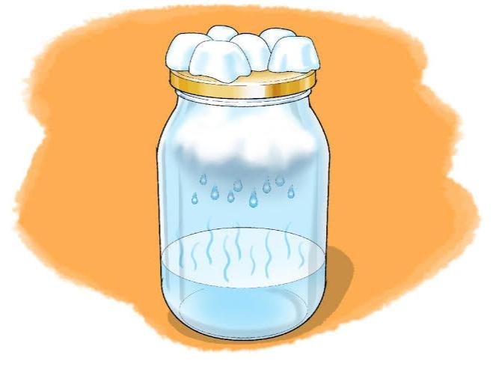
Reason (R): Matter can exist in solid, liquid, and gas forms, and all can be present at the same time.
A. Both A and R are true, and R is the correct explanation of A.
B. Both A and R are true, but R is not the correct explanation of A.
C. A is true, but R is false.
D. A is false, but R is true.

