HOTS
Suppose one day you spot one mysterious rabbit on the road, will you chase the rabbit like Alice did? Why / Why not? (Mention 2 points). Sketch your own fantasy rabbit and describe it’s appearance in words.

Ans- Yes/No
The reasons are:

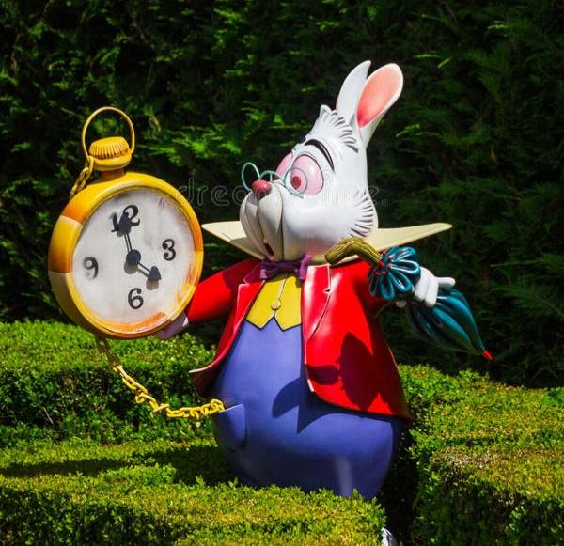
The rabbit is a very important character in Alice in Wonderland! He walks on _____ legs. But he's not just any bunny – he wears a _________, which is like a small jacket, and always has a_______ . He's very ______ and always in a _______, often saying, __________. He sometimes wears little glasses and _______ too, looking very _______ and ______

