Chapter – 10
Hu-Tu-Tu-Tu
- Write the importance of games and sports in our life.
Ans: The importance of games and sports in our life are :
a. Games and sports improves physical and mental health.
b. They promote creativity and social interaction.
c. Boost self-confidence and time management.
d. Improves teamwork and cooperation.
e. Teaches discipline and gives way to our academic improvements.
2. Mention the difference between Games and Sports.
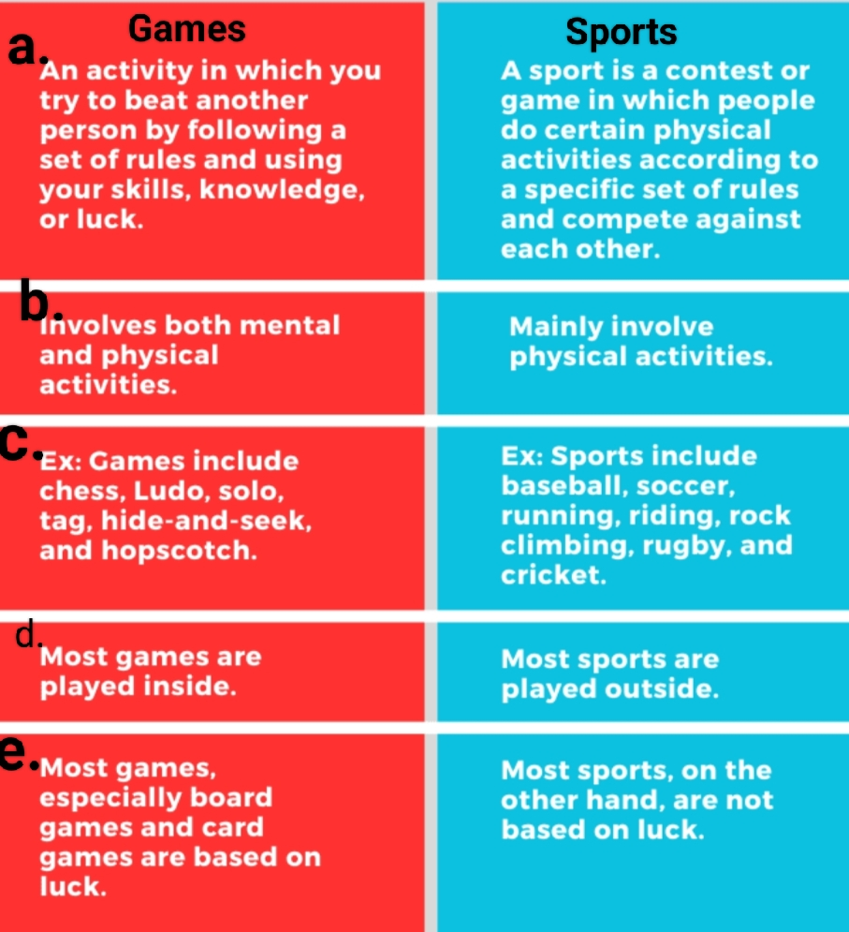
3.Every games or sports are played by following certain rules. Why?
Ans: Rules are important in any game or sport to ensure –
- Fair play and equality.
- Safety of players.
- Fair judging .
- Avoiding chaos.
- Making positive environment .
4.Team spirit makes the impossible possible.
i). What is Team spirit?
ii). What are the ways to maintain team spirit?
Ans:i) Team spirit is the spirit acquired by working together and establishing unity among the team members.
ii). Team spirit can be developed by:
- Avoiding discrimination.
- Avoiding conflict among team members.
- Celebrating success .
- Building trust and communicating with team members.
5. Discrimination can destroy the values of team spirit.
i). What do you mean by discrimination?
ii). What are the factors on which discrimination happens?
Ans:i) Discrimination means to treat someone or a group differently based on factors like-caste,skin colour,gender,etc.
ii) Factors on which discrimination happens include –
*Gender
*Caste
*Class
*Locality etc.
* Economic status
6. Girls were not allowed to play sports in the past. Why?
Ans: It was believed that girls are weak and cannot play outdoor sports as they require high endurance and physical ability. It was also believed that if they will wear men’s cloth for playing then they will never get married.
7.Write the role of a coach in sports.
Ans: Coach in a game has the following responsibilities
# To guide the players about fair play.
# To maintain the team spirit.
# To teach the rules and regulations of the game.
# To motivate the players.
Home work
8. Write the benefits of playing outdoor games or sports with examples.
9. Carrom is a game not sports. Explain.
10. Write the role of women in sports by giving two examples.
Do in EVS Activity Copy
Paste pictures of 10 women sports persons from India.
Write their name and the sport or game they play.

