️ Specimen Picture Composition:
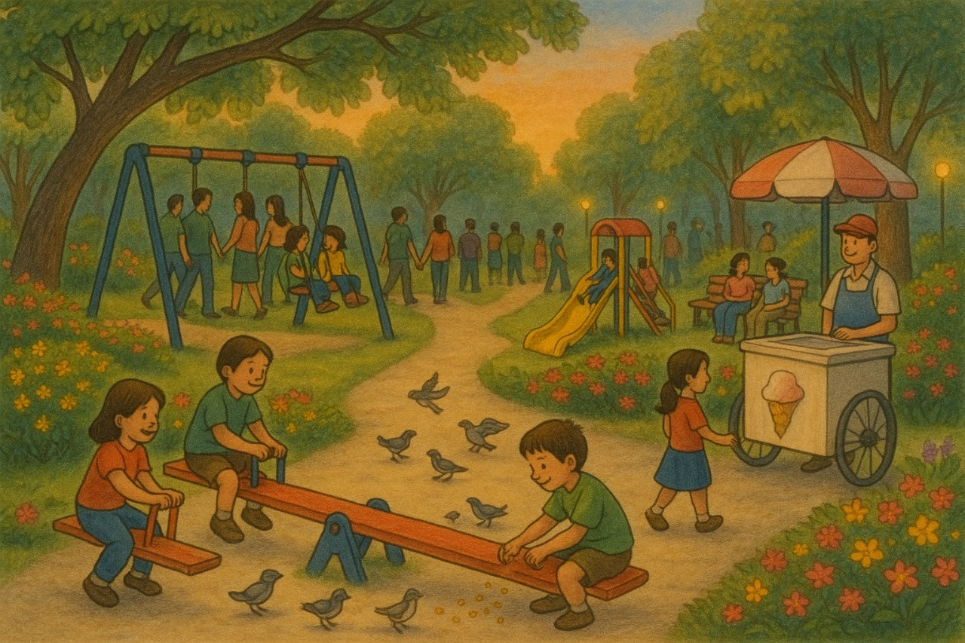

A Visit to the Park
Yesterday evening, I went to the park near my house with my parents. The weather was cool and pleasant. The park was full of people. Some were walking on the path while others sat on benches and talked. Children were playing happily. I saw a few of them on the swings, while some were sliding down the slide. One boy was feeding grains to the birds. The birds looked happy and flew around him. I also saw an ice-cream seller near the gate. Many children were buying their favourite flavours. The park had many green trees and colourful flowers. Everything looked fresh and peaceful. I played on the see-saw with my friend and had a lot of fun. It was a lovely evening.

✅ Tips for Students:
- Look at every part of the picture carefully.
- Write 7–10 sentences in simple English.
- Use naming words (nouns) and action words (verbs).
- Describe what is happening, not just what is there.

