Revision Work sheet
1)
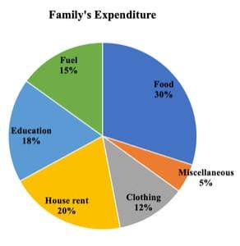

From the above given figure, find out the difference between the percentage of Education and Food
a)15% c)12% b)8% d)2%
2) In a certain code ‘MONEY ‘ is written as ‘XDMNL’. How is ‘ GREEN ‘ written in that code?
a)MDDQF b)DDFQ c)FFQDD d)QQFDQ
3) In a certain code, COVER is coded as 18522153, APPLE is coded as 221216161. What will MATHS be Coded as?
a)12548947 b) 11455978 c) 55874494 d) 19820113
4) If ‘paper’ is called ‘wood’, ‘wood’ is called ‘straw’, ‘straw’ is called ‘glass’, ‘glass is called ‘rubber’ and. Rubber’ is called ‘cloth’, then primarily, furniture is made up of ?
a)straw b)paper c)glass d) button
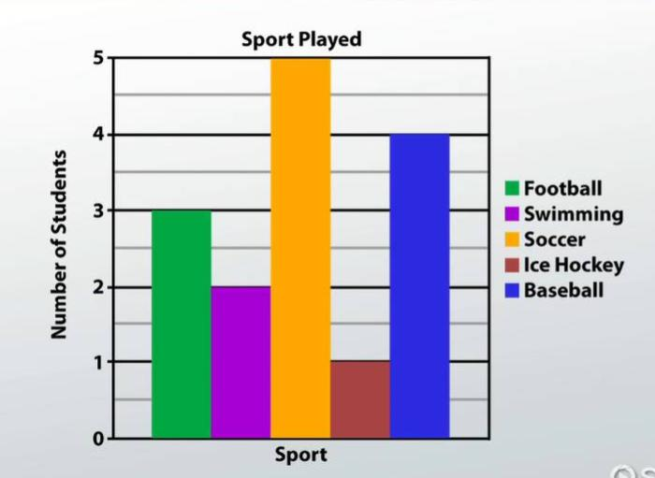
5)

How many more football played students are needed to make it equal to the soccer played students?
a)2 b) 4 c)3 d) 1
6) Look at this series: 2, 1, 1/2, 1/4, ... What number should come next?
a) 1/3 b)1/8 c)2/8 d)1/16
7) Look at this series: F2, __, D8, C16, B32, ... What number should fill the blank?
a)A16 b)G4 c)E4 d)E3
8) If A + B means A is the brother of B; A - B means A is the sister of B and A x B means A is the father of B. Which of the following means that C is the son of M?
a)M - N x C + F
b)F - C + N x M
c)N + M - F x C
d)M x N - C + F

9) If SUN is written as 54; MOON is written as 57. How EARTH will be written in that code language?
a) 32 b) 52 c) 30 d) 54

10) Introducing a boy, Annapurna said, "He is the son of the daughter of the father of my uncle." How is the boy related to the Annapurna?
a)Brother b)Nephew c)Uncle d)Son-in-law

11) Find the odd one:
a)dollar b)peso c)ounce d)euro
12) What is the type of angle is made by hand and back in the given yoga posture?
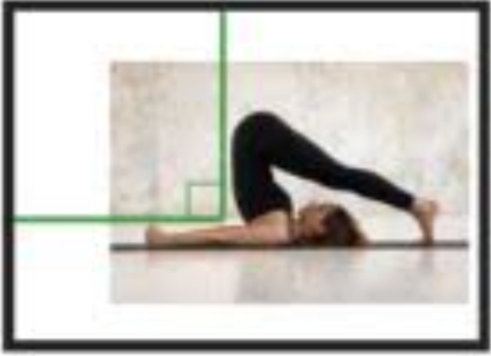
- Right angle c) straight angle

- Acute angle d) reflex angle

Answers :
Check please
1.c
2.a
3.d
4.a
5.a
6.b
7.c
8.b
9.b
10.a
11.c
12.a

