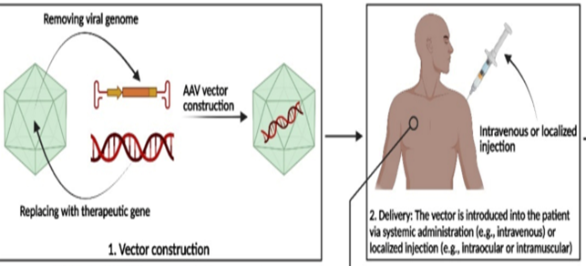

GENE THERAPY THROUGH VIRUS AS VECTOR

