Chapter no. 11
Valley of flowers
1.Write about the main parts of a flower and their functions.
Ans:
Pedicel – This is a tiny stalk that supports a single flower.
Sepal (calyx) – This protects the unopened flower i.e. the bud. It appears green and leaf-like.
Petal (corolla )- This is usually brightly coloured to make them attractive .
Stamen- This is the male part of a flower
- Filament -This is long and stalk like holding the anther.
- Anther – Pollen grains are produced and stored inside the anther.
Pistil (carpel)- This is the female part of a flower.
- Stigma- This receives and collects pollen grains. It is sticky in nature.
- Style – This connects stigma to the ovary .
- Ovary- This is the future fruit containing future seeds called ovules.

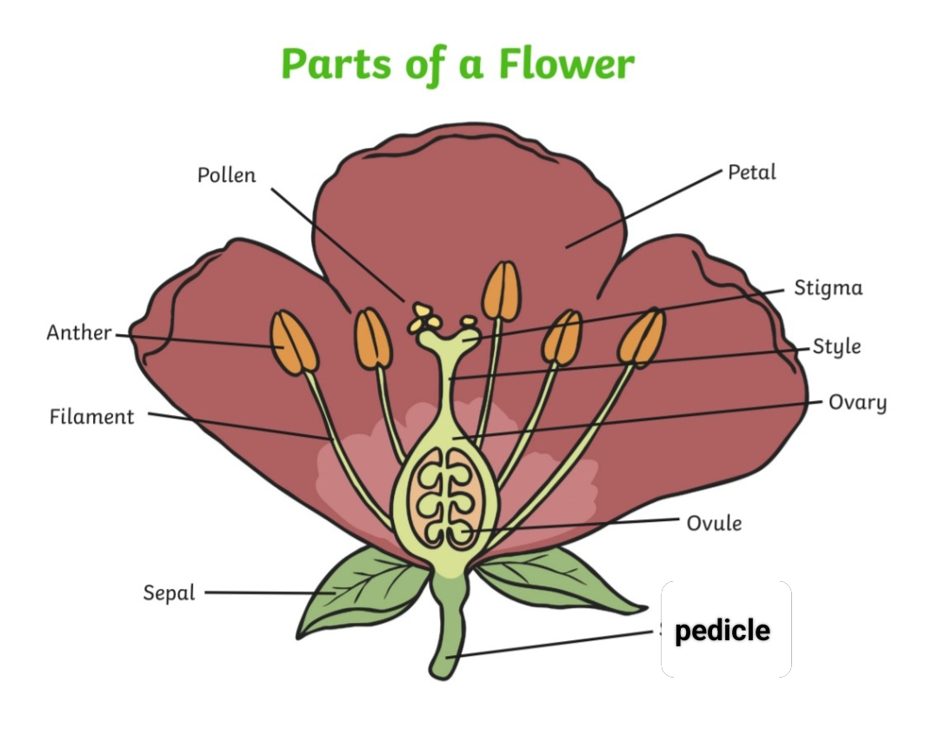
2. Define imperfect flower and perfect flower.
Ans: If a flower has only the male part or the female part, it is called imperfect flower.
Ex- Cucumber, corn etc.
If a flower has both male and female parts together, it is called perfect flower.
Ex- apple, rose etc.

