MOTION AND TIME
Class -VII F.M= 10
1.Assertion (A): The distance–time graph of an object moving with constant speed is a straight line.
Reason (R): In uniform motion, equal distances are covered in equal intervals of time.
a) Both A and R are true, and R is the correct explanation of A.
b) Both A and R are true, but R is not the correct explanation of A.
c) A is true, but R is false.
d) A is false, but R is true.

2.Assertion (A): The motion of a simple pendulum is an example of non periodic motion. Reason (R): The pendulum bob repeats its oscillation after regular intervals of time.
a)Both A and R are true, and R is the correct explanation of A.
b) Both A and R are true, but R is not the correct explanation of A.
c) A is true, but R is false.
d) A is false, but R is true.
3. The motion of the hands of a clock is an example of:
a) Rectilinear motion
b) Oscillatory motion
c) Circular motion
d) Periodic + Oscillatory motion
4. A simple pendulum takes 32 seconds to complete 20 oscillations. Its time period is:
a) 1.2 s
b) 1.4 s
c) 1.6 s
d) 2.0 s
5. In a 100-metre race, the runner who will be the fastest is the one who:
a) Takes the shortest time to finish
b) Covers the maximum distance
c) Runs at constant speed only
d) Takes the longest time to finish
6. Read the Case study and solve the following:

A school picnic bus leaves the school at 8:00 a.m. to go to a park which is 48 km away. For the first 12 km, it moves slowly through traffic at 24 km/h. Then it travels the next 24 km on the highway at 48 km/h. After that, it stops for 10 minutes at a roadside café. The last 12 km is covered on a village road at 30 km/h.

1.At what time will the bus reach the park? (2)
2.How far has the bus travelled by 9:00 a.m.? (1)

7. Following is a distance vs time graph of Amit’s journey from his home to park.
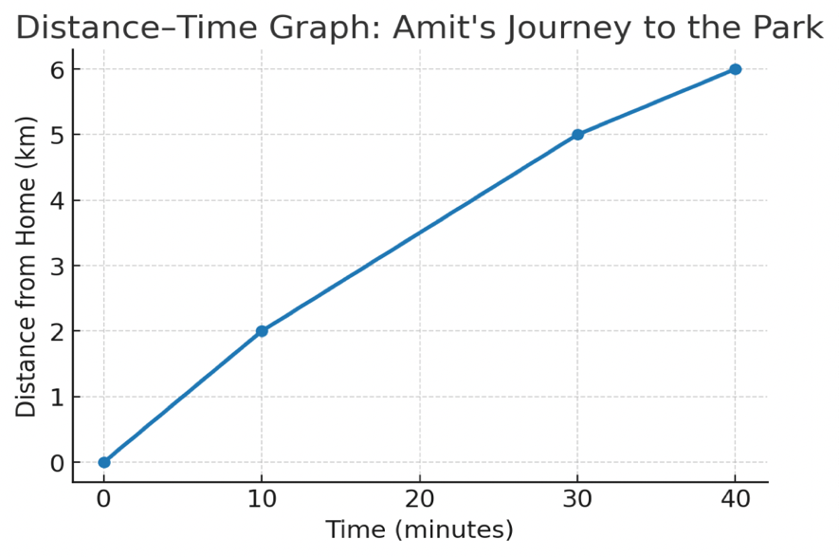
1.From the graph, find how much total time does Amit take to reach the park? (1)
2. Find his average speed for the whole journey in km/hour (1)

