CH -11
SUNITA IN SPACE
Q1. Rahul was excited to observe the full moon one night, but he noticed that the Moon slowly started getting darker and eventually appeared reddish in color. His elder sister told him that a lunar eclipse was happening.
- Based on this situation, explain what is lunar eclipse ?
- During total lunar eclipse is the moon visible from earth ? Write about its appearance from earth .
- Draw a diagram showing Total lunar Eclipse .
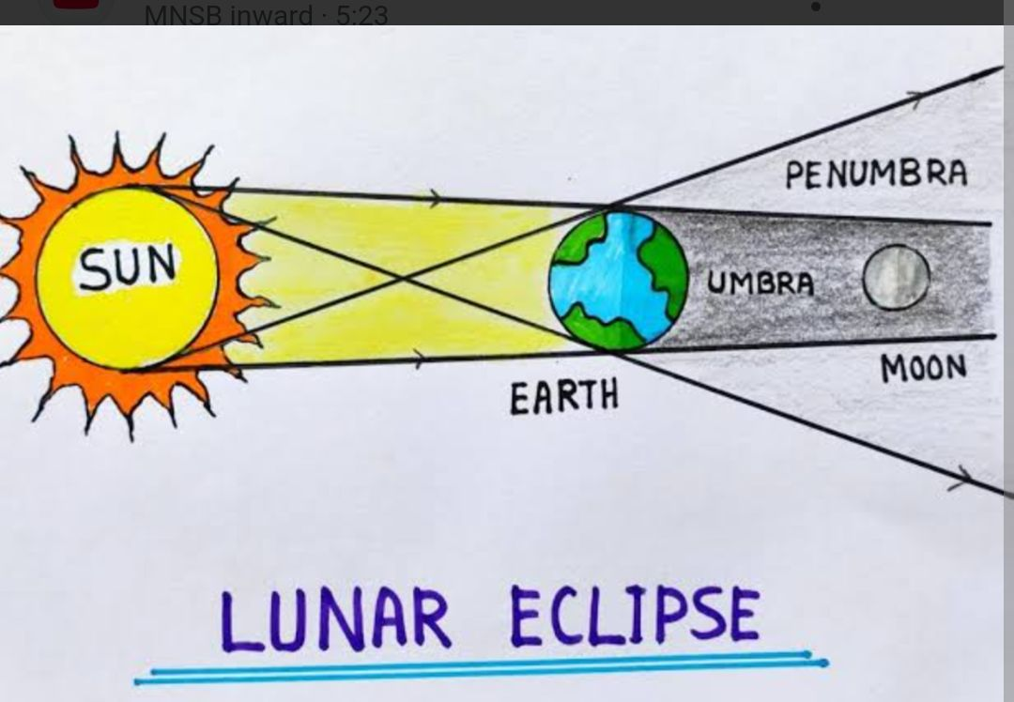
Answer :A) lunar eclipse occurs when the Earth comes between the Sun and the Moon, and the Earth's shadow falls on the Moon.

Q2. During a full moon night, Riya and her friends observed a lunar eclipse. While watching the sky, Riya noticed that the Moon appeared completely dark at one point, but earlier it was only partially shadowed.
What causes the Moon to appear partially shadowed at first and then completely dark during a lunar eclipse?
Answer - During a lunar eclipse, the Earth's shadow has two parts: the umbra and the penumbra. The umbra is the dark, central part of the shadow where the Sun is completely blocked by the Earth. The penumbra is the lighter, outer part of the shadow where the Sun is only partially blocked.
Q3 . Gravity is the force that pulls objects toward each other — especially toward the center of Earth .

A)If gravity pulls everything down, why don’t birds and airplanes fall?
Answer:
Because birds and airplanes push air down with their wings. This creates lift, which helps them stay up. But gravity is still pulling — they just fly by pushing against it.
B) If you drop a ball and a feather, which hits the ground first? Explain your answer ?

Q4 . The Earth's atmosphere is composed of several layers, each with distinct characteristics.
With help of a diagram show different layers of atmosphere .

