CLASS TEST
GRASSROOT DEMOCRACY – GOVERNANCE
F.M: 10
MCQ ‘s (1 MARKS EACH)
1.During the COVID-19 lockdown, some people went to court saying that children should also get mid-day meals even when schools were closed. The court ordered the government to continue providing food.
This shows the judiciary’s role in governance as:
a) Making new laws for the country
b) Checking if government actions are fair and protecting people’s rights
c) Enforcing rules like the police
d) Running schools directly
2.Which of the following statements about the levels of government is WRONG?
a) The Central Government makes laws about currency and defence.
b) The State Government can make rules about schools and agriculture.
c) The Local Government is responsible for providing clean drinking water in villages and towns.
d) The State Government decides foreign policy with other countries.
3.Which level of government is primarily responsible for local issues like sanitation and street lighting?
a) Central Government
b) State Government
c) Local Government
d) Judiciary
4.Picture Based Questions
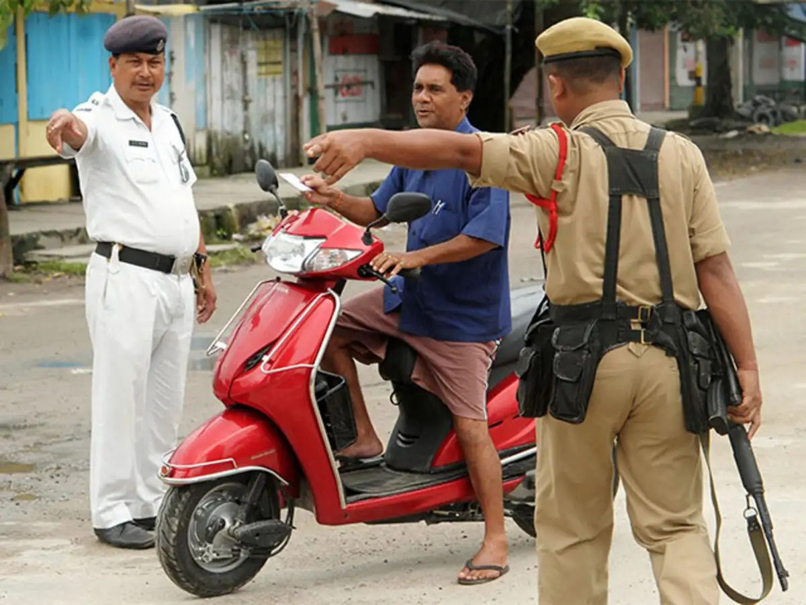

i) This picture represent which organ of the government?
a) Legislature
b) Executive
c) Judiciary
d) Election Commission
4. ii)Connect this picture with the idea of governance. Why do we need rules in our daily life?(1)
5.Explain the roles of the Legislature, Executive, and Judiciary in governance. Give one suitable real-life example for each. Why must these three organs remain separate but still work together? (4+1)

