1. Find the correct answer
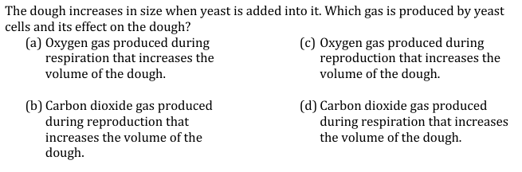
2. Find the correct answer
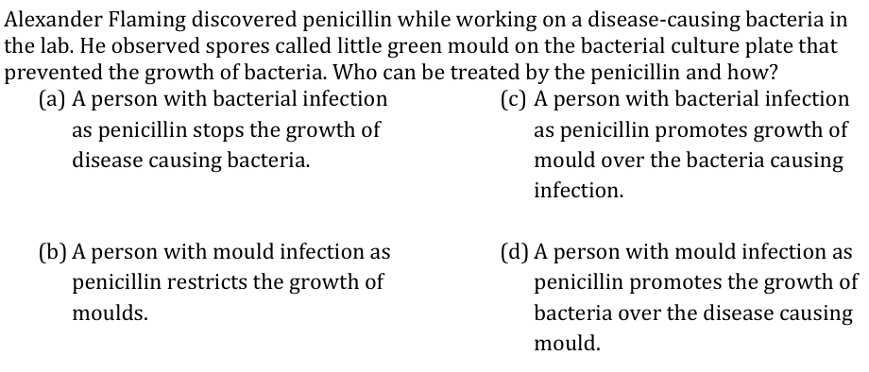
3. Find the correct answer
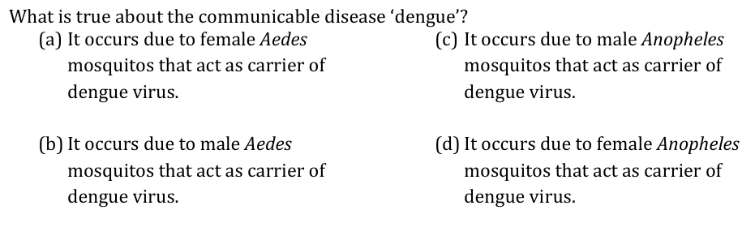
4. Find the correct answer
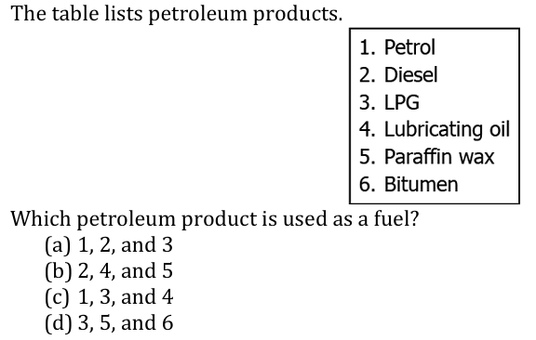
5. Find the correct answer
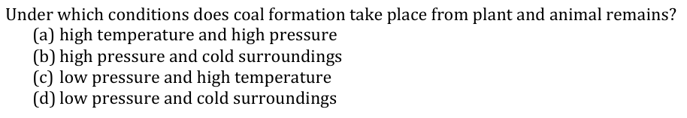
6. Write the Nitrogen cycle and explain the entire process. 2+3=5
7. Draw the destructive distillation process and explain the reason of using this method. 2+ 1=3
8. Write the concept of a. Vaccine b. Fractional distillation 2

