VERBS
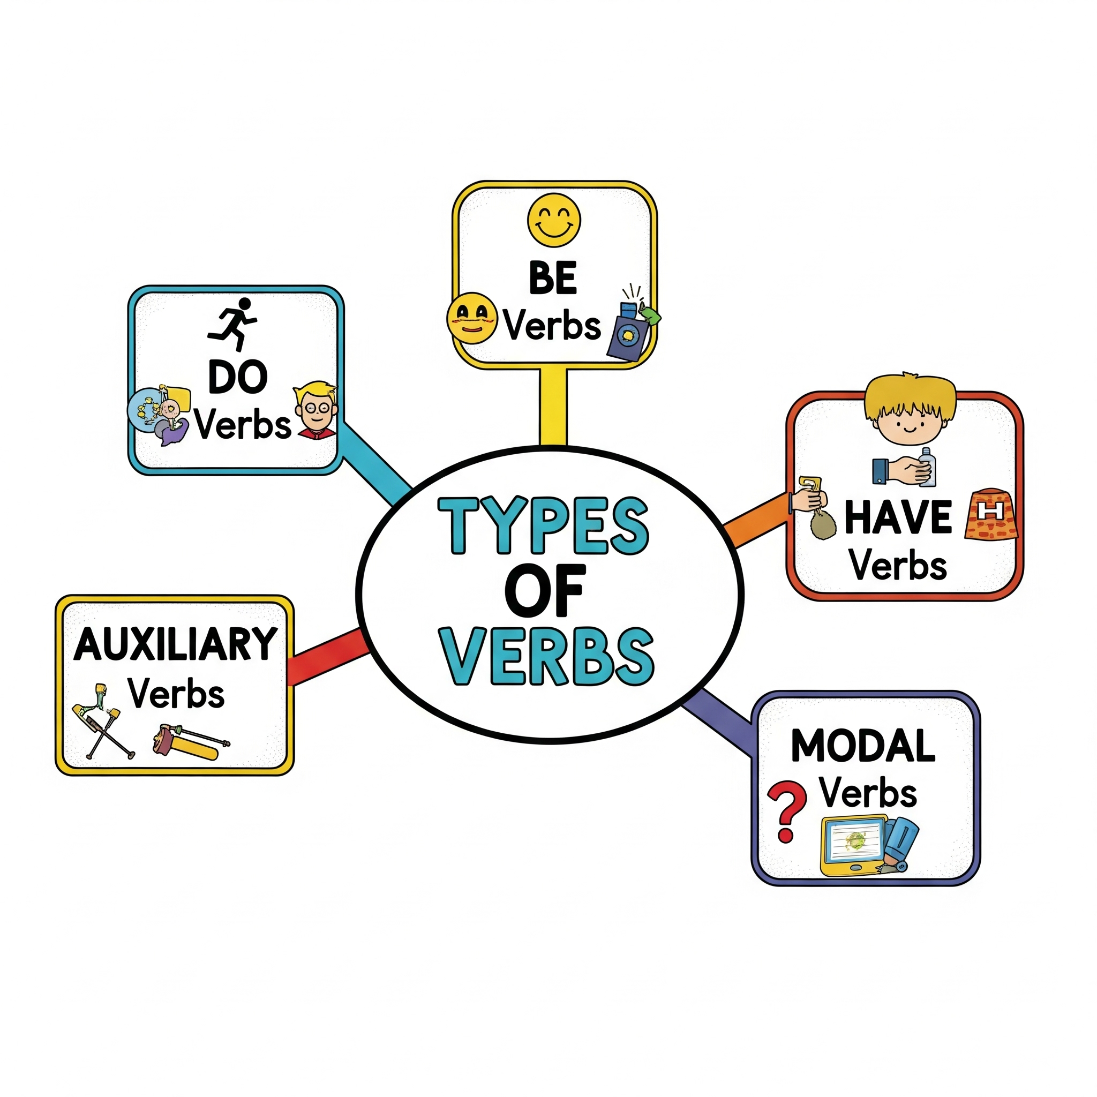
Verbs are action words that describe what the subject of a sentence is doing or what state it is in.

- “Be” Verbs
​These are linking verbs. They connect the subject of a sentence to a noun or adjective that describes it.
​Examples: is, am, are, was, were.
​Sentence Example: The dog is happy.

- “Do” Verbs
​These are action verbs.
​Examples: Do, Does, Did
Person | Singular | Plural
1st Person | I do my homework everyday. | We do our homework every day.
2nd Person | You do the work . | You do the work.
3rd person | She/He does the work properly. | They do the work properly.

- Use of ‘Do verb’ in framing negative sentence
Eg- She eats apple ➡️ She doesn’t eat apple. (Negative)
She ate apple ➡️ She did not eat apple.

- ​“Have” Verbs
​These verbs are a type of helping verb. They are used with another verb to show an action that has been completed.
​Examples: has, have, had.
​Sentence Example: She has finished her homework.
​

Choose the correct verb from the words in the brackets to complete each sentence:
Hint:
[She _____(make) a clay toy when she was in school.
Ans- She made a clay toy when she was in school.]
- ​My mom ___ a delicious cake for my birthday yesterday. (bake)
- Everyday she ___ for her friends at the park jn the evening. (wait)
- The sun ___ brightly in the morning. (shine).
- I ___ a new bicycle. (has).
- The dog ___ loudly at the stranger. (bark).
- She ___ doing her homework now. (Be)
- The children ___ happy to see the zoo animals. (Be)
- They ___ a new car. (Has)
- The bird ___ building its nest in the tree. (Be)
- I ___ a storybook everyday before I sleep. (read)

Answers
- Baked
- Waits
- Shines
- Have
- Barked
- Is
- Are
- Have
- Is
- Read

