Nature’s treasure
1. Assertion (A): Excessive use of fossil fuels leads to global warming.
Reason (R): Burning fossil fuels increases the concentration of greenhouse gases like carbon dioxide in the atmosphere.
A. Both A and R are true, and R is the correct explanation of A.
B. Both A and R are true, but R is not the correct explanation of A.
C. A is true, but R is false.
D. A is false, but R is true.
2. Assertion (A): Use of CNG in vehicles is promoted in many cities.
Reason (R): CNG burns more completely and causes less air pollution compared to petrol or diesel.
A. Both A and R are true, and R is the correct explanation of A.
B. Both A and R are true, but R is not the correct explanation of A.
C. A is true, but R is false.
D. A is false, but R is true.
3. Assertion (A): Rocks are composed of minerals which are basic components of metals like gold, copper etc.
Reason (R): Dead plants and animals get buried under layers of sediments of sedimentary rocks.
- Both A and R are true, and R is the correct explanation of A.
- Both A and R are true, but R is not the correct explanation of A.
- A is true, but R is false.
- A is false, but R is true.
4. Observe the picture carefully and answer the following questions –
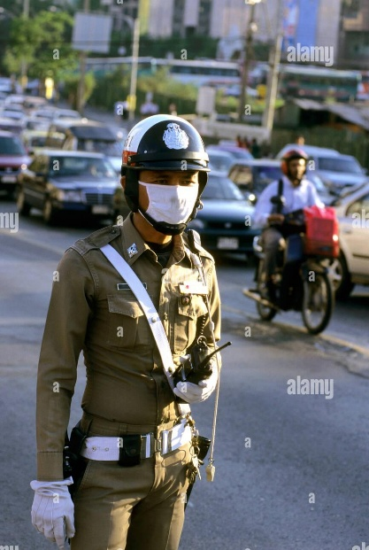
A. What is covering the nose and mouth of the police man?
B. Why does he put a cover on his nose?
C. Describe the air quality of the place shown in the image.
D. What can be done to change the quality of the air?

