SATISH CHANDRA MEMORIAL SCHOOL
HOTS TEST (2025-26)
CLASS IX
SOCIAL SCIENCE
Maximum Marks: 16

1.You are a travel blogger visiting the Northern Plain known as the 'granary of India'. Discuss the role of physical features in making it agriculturally productive. 4

2.“Farm labourers are the worst sufferers in terms of employment.” Identify anyfour major problems faced by them. 4
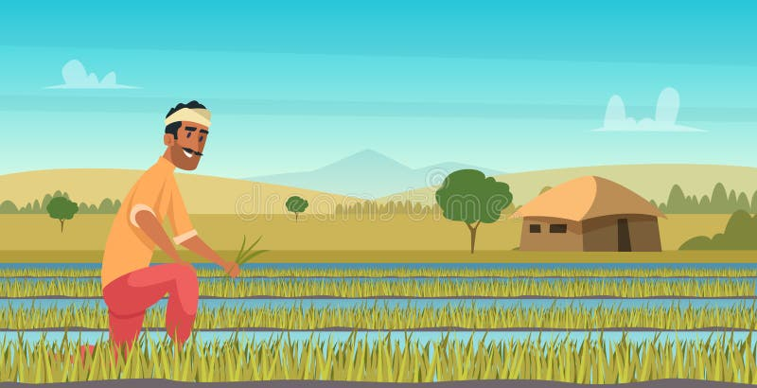
3. ‘The Russian Revolution was not just a political event but a social and economic transformation.’ Justify this statement with suitable arguments." 4
4. "Elections are a cornerstone of democracy." Justify this statement by explaining two conditions necessary for free and fair elections in a democracy. 2
5. Critically examine the role of money and muscle power in Indian elections. How does it affect electoral outcomes? 2

