Revision worksheet
Magnet
Situation -1 Meena placed a magnet under a cardboard sheet. When she scattered iron nails on top, they started moving and gathered over one spot. What does this tell us about magnetic force?
a) Cardboard is a magnetic material
b) Magnetic force works only when there is no obstacle
c) Magnetic force can pass through non-magnetic materials
d) Nails are naturally magnetic

Situation-2: Avi stuck a magnet to the side of his metal pencil box, and noticed that paper clips inside were pulled toward the inner wall—even though the magnet didn’t touch them. Which property of magnets explains this?
a) Magnets pull only when in direct contact
b) Magnetism works only with liquids
c) Magnetic force acts through magnetic objects only
d) Magnetic force can pass through certain materials

3.Assertion (A): An aluminium rod does not get attracted to a strong magnet, even though aluminium is a metal.
Reason (R): All metals are magnetic, but some require stronger magnets to show attraction.
a) Both A and R are true, and R is the correct explanation of A.
b) Both A and R are true, but R is not the correct explanation of A.
c) A is true, but R is false.
d) A is false, but R is true.

4.Situation-4: Sneha placed a plastic ruler, an iron key, a wooden block, and an aluminium strip near a magnet. Only the iron key was attracted to it. Why was the iron key attracted to the magnet while the others were not?

5.Situation-5 Aryan was hiking with a compass. As he passed under high-voltage electric lines, his compass needle spun erratically and wouldn’t settle in one direction.
(a) Explain why the compass needle behaved strangely under electric wires.
(b) What does this tell us about the effect of surrounding forces on a compass?

6. Observe the following diagram and answer the following questions –
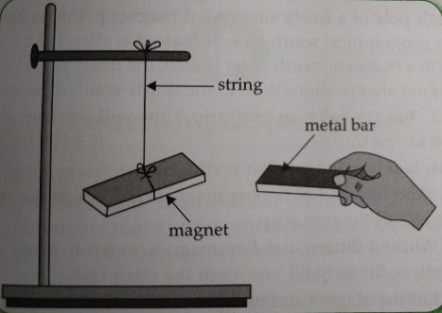
A. Does the magnet move towards the bars?
B. Write two important properties of a magnet.
C. A mixture contains sand and iron dust. How can the iron dust be separated from sand?
a) Blow air over the mixture.
b) Sieve the mixture using a strainer.
c) Pour water into the mixture and then filter it.
d) Spread the mixture and run a magnet all over it.

