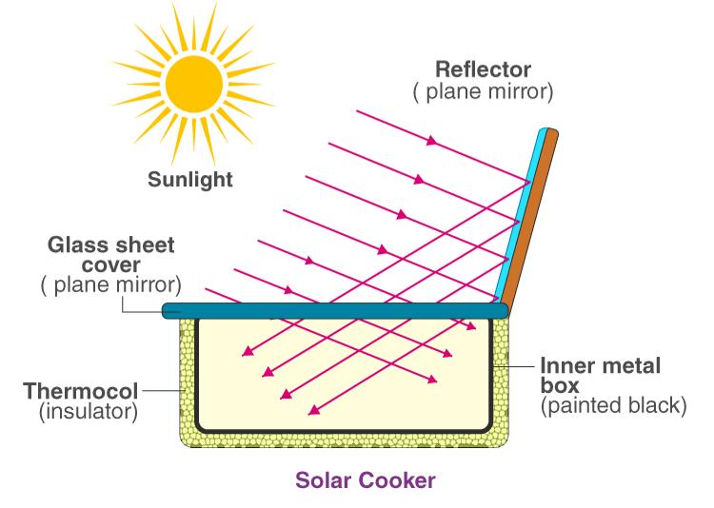SOLAR COOKER
Benefits of using solar cooker –
- Saves fuel – It does not require LPG, kerosene, coal, or electricity.
- Eco-friendly – No smoke, no air pollution, and no greenhouse gases.3.
- Low cost – After one-time purchase, there is no running cost.
- Safe to use – No risk of fire or gas leakage.
- Nutritious food – Food cooks at moderate temperature, so vitamins and minerals are preserved.
- Renewable energy – Uses sunlight, which is freely and abundantly available.
- Reduces deforestation – Less dependence on firewood.

Q: Observe the given image carefully and answer the following questions:
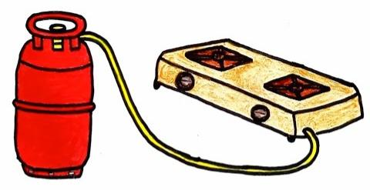
  - Write the full name of the fuel that is present inside the cylinder.
  - Write the major component of this fuel.
  - What is the molecular formula of the major component of the fuel?
  - What is the main source of the main component used in this cylinder?
  - In which state the fuel is present inside the cylinder? Justify your answer.
  - In which state does the fuel comes out of the cylinder?

