Case study
Nowadays, engineers design architectural structure like houses, building, monument etc. sometimes , we can find a sort of dampness in the walls. At the time of surveying Golconda Fort, Mohit expressed his views in a very surprising way.
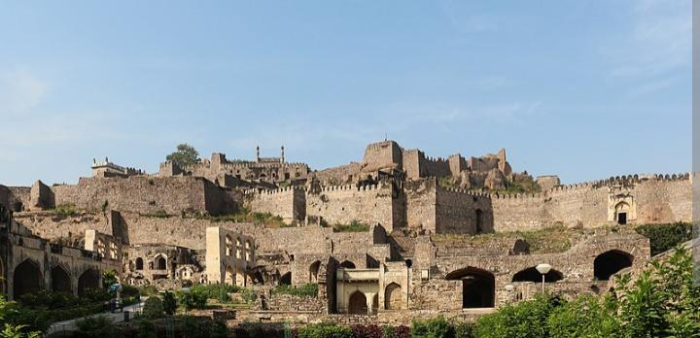

1.Who build the Golconda fort? (1)
A. Lodhi dynasty B. Kalji dynasty C. Tughlaq dynasty D. Qutubshahi dynasty.

2. What arrangements would have been made in the building for air and light?

3. Inside the fort the most amazing engineering for which Mohit was surprised? What is special about that engineering?
4.Do you think any difference in the walls of today's houses with compared to the walls of Golconda Fort?

HOTS QUESTIONS
- It was a lot of fun living in space but it was also difficult. State one incident which was fun for them and one reason why the same fun is a difficulty also.

- A scientists who peeps into mosquito stomach. What contribution has he made in the field of science?

4.Iron deficiency is the most common and widespread nutritional disorder in the world . What problem arise due to deficiency of iron in our body? What diet we should take to overcome this problem.

