SATISH CHANDRA MEMORIAL SCHOOL
Practice Test (Case Study based Questions)
SCIENCE
Class VII
Time: 40 Minutes Maximum Marks: 14

CASE STUDY 1
Ravi and Sita are preparing for their school's annual sports day. They have to run a 200-meter race. Ravi runs at a constant speed of 5 meters per second, while Sita runs at a constant speed of 4 meters per second.
1. Calculate the time it takes for Ravi to complete the race. (1)
- 40 s b) 50 s c) 60 s d) 80 s

2. Determine the time it takes for Sita to finish the race. (1)
- 40 s b) 50 s c) 60 s d) 80 s

3. If both start running at the same time, how much sooner does Ravi finish the race as compared to Sita? (1)
- 6.66 s b) 10 s c) 16.66s d) 26.66s

4. If Ravi decreases his speed to 2 meters per second, how much more time does he take as compared to his original time? (1)
- 30s b) 40s c) 50s d) 60s

5. If Ravi and Sita decided to run in a relay race where each would cover half of the 200-meter distance and speed for Ravi and Sita is the same as original then how much distance each runner will cover? Calculate the time taken by each to run their respective distances where their speed remains same.( show mathematical calculation in rough work) (2)
- 100 m, Time taken by Ravi to complete race is 20s
100m, Time taken by Sita to complete race is 25s
- 200 m, Time taken by Ravi to complete race is 20s
200m, Time taken by Sita to complete race is 25 s
- 100 m, Time taken by Ravi to complete race is 25s
100m, Time taken by Sita to complete race is 20 s
- 200 m, Time taken by Ravi to complete race is 25
200m, Time taken by Sita to complete race is 28 s

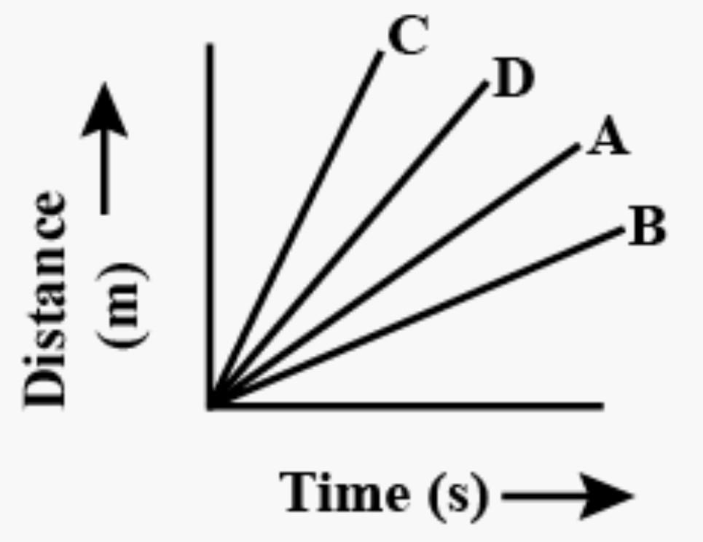
6. Four cars A, B, C and D are moving on a leveled road. Their distance versus time graphs are shown in the given figure. Choose the correct statement (1)

- Car A is faster than car D.
- Car B is the slowest.
- Car D is faster than car C.
- Car C is the slowest.

CASE STUDY 2
Dialysis is a medical procedure that acts as an artificial kidney, removing waste products and excess fluid from the blood when the kidneys are unable to do so, typically due to kidney failure. It helps maintain a stable internal environment (homeostasis) in the body, managing conditions like acute kidney injury or chronic kidney disease.
1. Kidney removes harmful ___A___ waste from the body in the form of __B___.
- A- nitrogenous waste, B- stool. b) A- carbon dioxide, B- urine.
c) A- nitrogenous waste, B- urine. d)A- carbon dioxide, B- stool.

2. Humans excrete ___A___ through urine. These kinds of organisms are said to be ___B__ organisms.
- A- urea, B- ureotelic b) A- uric acid, B- uricotelic
c) A- ammonia, B- ammonotelic d) A- urea, B- uricotelic

3. During the dialysis process when blood is going outside of the body it remains in a fluid form because in the dialysis machine______ is present which is not letting the blood to clot.
- Plasma b) anticoagulant c) coagulant d) leukocytes

4. What is the primary function of dialysis?
a) To remove excess glucose from the blood b) To filter waste products from the blood
c) To regulate body temperature d) To produce hormones

5. What is a common symptom of kidney disease?
- Increased urine output. b) Decreased urine output
c) Frequent headaches d) Joint pain

6. Which of the following is a symptom of kidney failure?
- Swelling in the feet and ankles b) Fatigue and weakness
c) Nausea and vomiting d) All of the above

7. What is a common symptom of kidney stones?
- Severe pain in the back or side. b) Blood in the urine
c). Frequent urination. d) All of the above

