1. Check the picture of glass electrode and answer the following 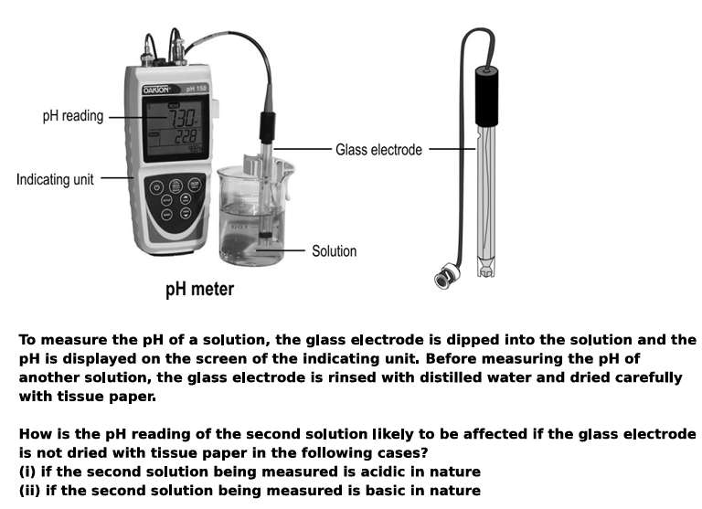
2. X is a highly corrosive mixture of concentrated two acids in a 3:1 ratio. It is known as "royal water" because it is one of the few substances capable of dissolving noble metals like gold and platinum.
a. Mention the name/formula of two acids.
b. How “dissolving” noble metals is different from dissolving sugar in water?
3. State a method to determine pH of a solution. pH of coffee is more or less 7?
4. Lemon juice can effectively clean tarnished copper vessels. Give reason. Mention the Copper corrosion reaction.
5. A metal oxide reacts with both HCl and NaOH. Ore of the metal is Alumina. Guess the metal and write the related chemical reactions.

