Revision worksheet
Q1. The statement which is not correct --
A. Marble is a metamorphic rock formed from limestone.
B. Granite is an igneous rock formed by cooled lava.
C. Sandstone is an igneous rock formed under heat and pressure.
D. Slate is a metamorphic rock formed from shale.

Q2. Choose the correct option:
A. Coal and petroleum are found in igneous rocks.
B. Fossil fuels are formed from dead plants and animals buried for millions of years.
C. Igneous rocks are the main source of fossil fuels.
D. Marble is a sedimentary rock rich in fossils.

Q3. Riya is travelling on a train moving at constant speed. She is sitting by the window, eating chips. Outside the window, she notices trees, fields, and poles rushing past quickly. Her school bag is kept on the seat beside her.
i) With respect to other passengers in the train, is Riya at rest or in motion?
ii) With respect to Riya, name the things that are at rest.

Q4. Rohit wants to measure the length of his classroom.
He has only a 30 cm ruler.
The classroom length is about 8 meters.
i) What difficulties might he face in doing this?
ii) Suggest a better instrument for measuring such a length and explain why it is more suitable.

Q5. Observe the diagram and answer the following questions 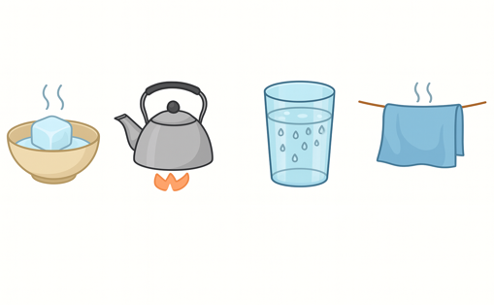
A. Clothes dry faster on a sunny, windy day than on a cloudy, still day.
Q. Which process is responsible for drying?

B. An ice cube is left on a bowl in a warm room. After it melts into water, the same bowl is placed in a freezer, and the water becomes ice again.
Q Name both processes.

C. On a humid day, droplets of water appear on the bathroom mirror after a hot shower.
Q. Name the process involved.

Q6.On Sports Day, an ice-cream tub melts in the sun. Later it’s kept in the freezer and becomes solid again

a. What kind of change is this? (reversible / irreversible)
b. Is any new substance formed?

Q7.Flour, water and yeast are mixed to make dough. After baking, it becomes a fluffy bread
a. Is the final change reversible or irreversible?
b. Can we get the original dough back from the bread?

