Product Bar Graph

Arjun picked apples from his garden on Monday, Wednesday and Friday respectively. Figure below represents how many apples he collected each day.

Monday | Wednesday | Friday
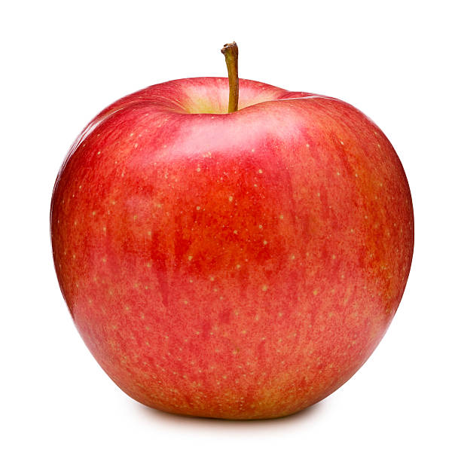 | 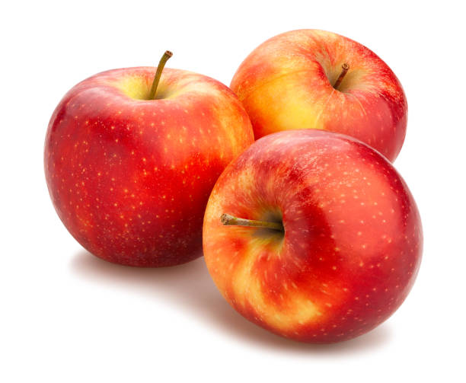 | 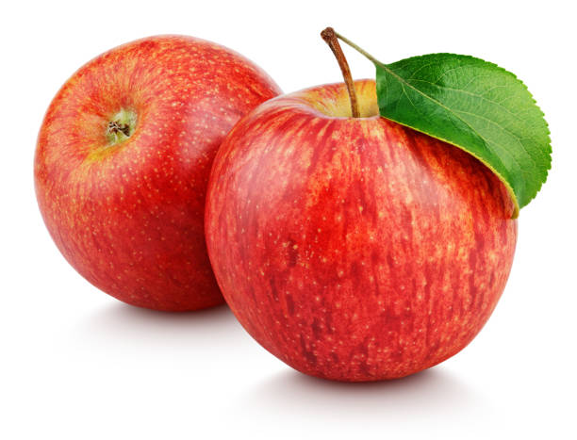

If one apple = 3, then plot the number of apples Arjun picked each day in the graph given below accordingly.

Answer the following questions:
1) On which day did Arjun pick least apple?
Ans: _________________________________
2) How many total apples did Arjun pick?
Ans: _________________________________

