WORKSHEET ON CORRECT VERB FORM
- Fill in the blanks with the correct form of the verbs given in brackets:
- He ……………….. (beat) the thief if he catches the man.
- She might catch the bus if she………………..(run) fast.
- They would have won if they ………………..(play) well.
- If you ……………….. (inform) me I would have reached the station.
- If she ………………..(not work) hard, she will fail.
- Unless they ………………..(request) me, I would not go.
- If you ……………….. (help) me, I would have completed this job.
- If I ……………….. (be) a bird I would fly to you.
- In case you ……………….. (see) Avish, give him this book.
- Unless she ……………….. (mend) her ways, she will suffer.
- Fill in the blanks in the following passages with the appropriate tense forms of the verbs given in brackets:
- My younger brother, Tinu, (a) ………………. (fall) off his bicycle yesterday. He (b) ……………….. (hurt) his right ankle and (c) ……………….. (be) in bed since then. The doctor (d) ……………….. just (examine) him and (e) ………………..(advise) him complete rest for a week. He hopes that Tinu (f) ……………….. (recover) soon.
- The match (a) ………………..(begin) before we reached the stadium. There (b)……………….. (be) a great rush at the gate. People (c) ……………….. (argue) with the security guards. Entering the stadium (d)……………….. (prove) a tedious job. I (e)……………….. (be) able to forget this nasty experience in the years to come. I (f) ………………..(decide) never to watch an event in an overcrowded place.
- When I (a)……………….. (look) at the Palace in the morning sunlight, I was amazed. It (b) ……………….. (seem) an architectural wonder. I (c) ……………….. (watch) it from different angles and (d) ……………….. (take) snaps. Perhaps my movements (e) ……………….. (make) the guards suspicious. They at once (f) ……………….. (catch) hold of my camera and spoke rudely to me.
- It is estimated that India (a) ……………….. (make) rapid strides in science in the coming years. For that we (b) ……………….. (need) good science teachers, labs and equipment. Unfortunately, the existing scenario (c) ……………….. (not present) an encouraging sight. The nation (d) ……………….. (lack) administrators with a vision. Scientists (e) ……………….. (be) more interested in foreign assignments than research at home. Students too (f) ……………….. not (lag) behind.
- you ever (a) ………………. (hear) of paperless office? You (b) ……………….. certainly (say), “no”. Well, very soon the old favourite of pen-pushers (c) ……………….. (make) an unceremonious exit. You (d) ……………….. already (see) it happening in the banks. Where (e) ……………….. (be) those bulky ledgers? A smart computer (f) ……………….. (replace) them quietly.
- Correct the following sentences using proper tense forms
- I am liking it very much.
- She is knowing you very well.
- Mohit is seeing the bus coming.
- It rains now, we can’t go out.
- Water vapour is condensing to form clouds.
- Madhu is always writing beautiful poems.
- The poem is going round the earth.
- These students prepare for their exams these days.
- Why do you work so hard today?
- My uncle has arrived from Mumbai last night.
- Ravi is owning two cars. ‘
- Reena reads at this moment.
- She do not finish her home work yet.
- If you will work hard, you will pass.
- I already sent a telegram to Manish, before I received your phone call.

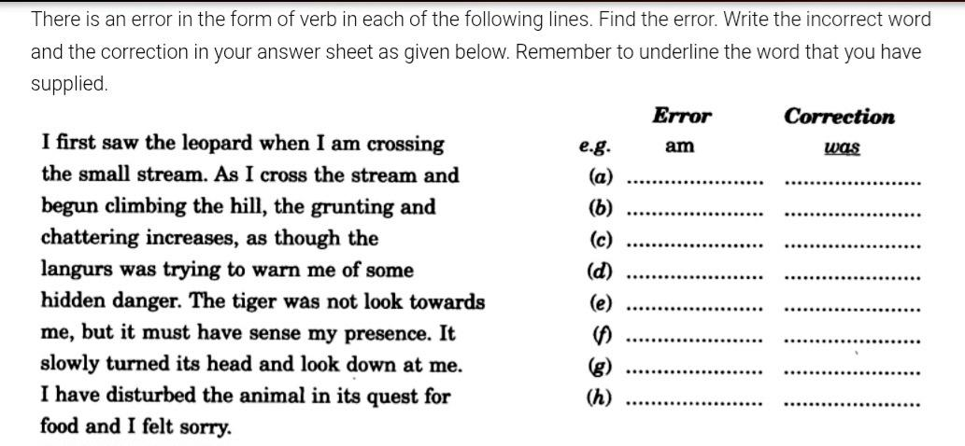

Answers of a:
1. will beat
2. ran
3. had played
4. had informed
5. does not work
6. requested
7. had helped
8. were
9. see
10. mends.

Answers of b:
- (a) fell (b) hurt (c) has been (d) has examined (e) advised (f) will recover
- (a) had begun (b) was (c) were arguing (d) proved (e) will not be (f) have decided
- (a) looked (b) seemed (c) watched (d) took (e) had made (f) caught
- (a) will (is going to) make (b) need (c) does not present (d) lacks (e) are (f) do not lag
- (a) Have…………heard (b) will………….say (c) will (is going to) make (d) have already seen (e) are (f) has replaced.
Answers for c:
- I like it very much.
- She knows you very well.
- Mohit sees the bus coming.
- It is raining now, we can’t go out.
- Water vapour condenses to form clouds.
- Madhu always writes beautiful poems.
- The poem goes round the earth.
- These students are preparing for their exams, these days.
- Why are you working so hard today?
- My uncle arrived from Mumbai last night.
- Ravi owns two cars.
- Reena is reading at this moment.
- She has not finished her homework yet.
- If you work hard, you will pass.
- I had already sent a telegram to Manish, before I received your phone call.
Answers:
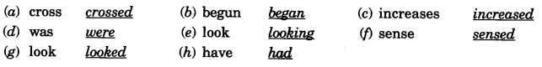

Fill-in-the-blanks
- The dog ___ by Sarah. [Feed/ Is fed]
- The trophy ___ by our team this year. [Is won/Was won]
- The students’ progress ___ regularly by their class teacher. [Is checked/Check]
- The mechanic ___ the car’s engine yesterday. [Was Repaired/ Repaired]
- She ___ a cake for the party. [Is Baking/ Was Baked]
- You ___ with all the necessary information by them. [ Will be intimated/ Intimate]
- The weeds in the garden ___ by him. [Are being trimmed/Trim]
- The principal ___ the student for misbehaviour. [Suspended/Is suspended]
- The teacher ___ the lesson to the students. [Explains/ Is Explained]
- My car ___ by myself yesterday. [Was fixed/Fixes]
- They ___ walk-in-interviews for 15 job posts. [Are conducting/Was conducted]
- A dacoit ___ red-handed by the villagers. [Catch/Was caught]
- His research ___ in a scientific journal. [Will be published/Publish]
- She ___ the managerial post by the company. [Was offered/Is offering]
- The audience ___ the band’s performance. [Applauded/ Is Applauded]
- The team leader ___ the task to his juniors. [Has assigned/Was assigned]
- Our cook ___ a special dish for the guests. [Is preparing/Is being prepared]
- Several houses ___ by the storm. [Were destroyed/Destroying]
- The election result ___ by the committee next week. [Announces/Will be announced]
- A charity event ___. [Organising/Was organised]
- She ___ this book to her friends. [Was recommended/Recommended]
- Burj Khalifa ___ by Mr. Adrian Smith. [Designing/Was designed]
- The company ___ Rohit a performance bonus. [Gave/Was given]
- Physics rules ___ in class by the professors. [Are explained/Explaining]
- The two brothers ___ the roof of the thatch. [Are fixing/ Was fixed]
- The police ___ the criminal yesterday. [Is caught/Caught]
- Devi ___ the task before Friday. [Will finish/Are finished]
- The members ___ the beautiful sea beach. [Are cleaning/Has been cleaned]
- The four walls of the room ___ pink by Shruthi. [Were painted/Paints]
- One candidate ___ for the job by the committee. [Has been selected/Selecting]
Answers:
- Is fed
- Is won
- Is checked
- Repaired
- Is Baking
- Will be intimated
- Are being trimmed
- Suspended
- Explains
- Was fixed
- Are conducting
- Was caught
- Will be published
- Was offered
- Applauded
- Has assigned
- Is preparing
- Were destroyed
- Will be announced
- Was organised
- Recommended
- Was designed
- Gave
- Are explained
- Are fixing
- Caught
- Will finish
- Are cleaning
- Were painted
- Has been selected

