Reproduction in plants
Reproduction is the biological process by which organisms produce new individuals, or offspring, of the same species. It is fundamental for the continuation of life and the survival of species across generations.
- Asexual Reproduction
  - Involves only one parent
  - Offspring are genetically identical clones of the parent
  - Common in plants, bacteria, fungi, and some animals
- Sexual Reproduction
  - Involves two parents
  - Offspring have genetic variation due to the combination of gametes (egg and sperm or equivalent)
  - Typical in most animals and many plant
1.Vegetative propagation
Roots
Some plants develop buds on their roots that grow into new shoots, forming independent plants.

Examples:
Sweet potato: Grows from root tubers.
Dahlia: Roots produce buds that sprout new plants.
Stems
The most common organ for vegetative propagation, especially modified stems.
Types:
a.Rhizomes (e.g., ginger, banana): Underground stems with nodes and internodes that sprout.
b.Tubers (e.g., potato): Underground stem stores nutrients and sprouts from 'eyes.'
c.Bulbs (e.g., onion): Short stem base with fleshy leaves stores food and grows into new plants.
. Rose , Sugarcane , China rose are often grown by stem cutting
Leaves
. Buds are present along the margins of the leaves
. At favourable conditions buds can form plantlets( small plant)
Examples:
Bryophyllum: Leaf margins grow tiny plantlets that detach and root.
Begonia: Leaf cuttings can develop into full plants.

1. Potato (tuber from stem)
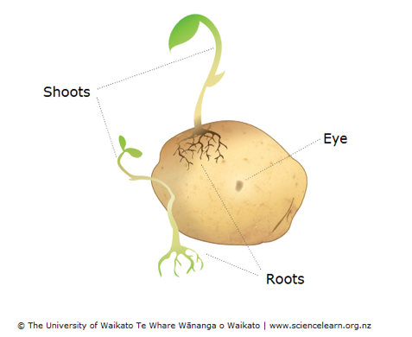
Key points:
- Potato tubers are modified stems (not roots) and have “eyes” or nodes from which new sprouts emerge.
- These tuber pieces act as vegetative “seeds” (but not sexual seeds) when planted.
- Each “eye” can develop into a new shoot + roots, producing a genetically identical clone of the parent plant.

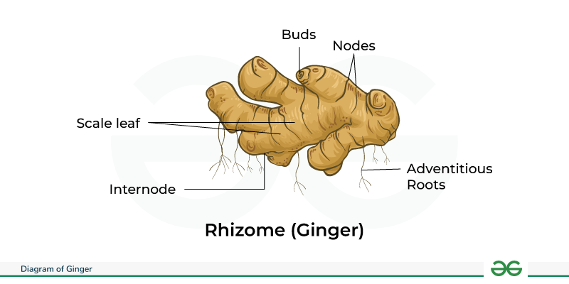

Key points:
- Ginger reproduces via its underground stem (rhizome) which bears nodes and buds.
- When portions of the rhizome with buds are planted, they grow into a full new plant — again genetically identical.
- The rhizome serves both as a storage organ and as a propagation organ.

3. Sweet Potato (storage root / vine cutting)

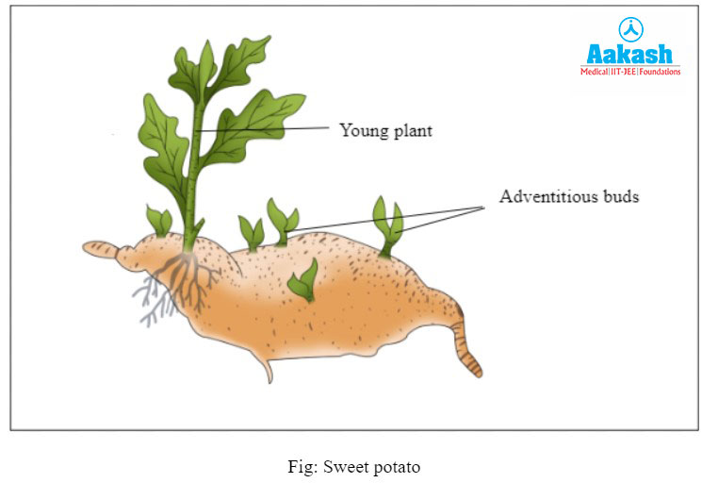
Key points:
- Sweet potato propagation commonly uses vine cuttings or the storage roots — rather than traditional seeds.
- The roots/stems have adventitious buds that develop into new shoots and roots.
- This method ensures uniformity and speed in propagation of sweet potato cultivars.

4. Bryophyllum (leaf-margin plantlets)

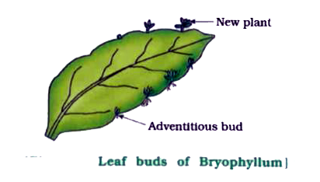

🟢 2. Budding
Definition:
1.A small bud (outgrowth) develops on the body of the parent organism.
2. The bud grows, matures, and finally separates to live as a new individual.
3.Sometimes a new bud arises from a bud which is still attached and chain of buds can be seen .
Examples:
Hydra (animal)
Yeast (fungus)

Process:
1️. A bud forms on the parent’s body.
2️. The bud enlarges and develops tentacles (in Hydra).
3️. It detaches and grows independently.

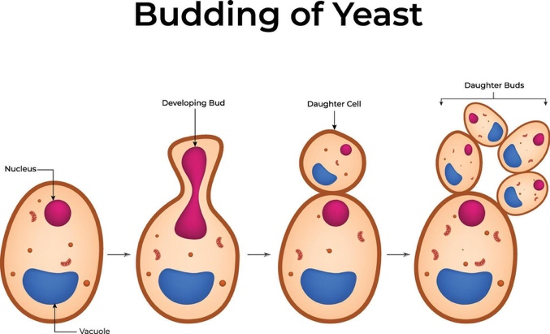

🟢 3. Spore Formation
Definition:
Some organisms produce very small, light, and tough spores inside a special case called a sporangium.
When spores are released, they float in the air and grow into new individuals under suitable conditions.
Examples:
Ferns
Mosses
Fungi (like Bread Mould)
- 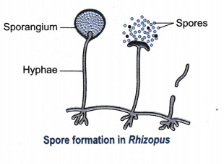

- Process:
1️.Spores form in the sporangium.
2️.When it bursts, spores are spread by wind.
3️. On moist soil, each spore grows into a new plant or fungus.

🟢 4. Fragmentation
Definition:
The body of the parent splits into two or more fragments, and each fragment grows into a complete new organism.
Examples:
- Spirogyra (green filamentous alga)
- Sea Sponge
Process:
1️. The organism naturally breaks into pieces.
2️. Each piece develops cells to form a new body.
