Artificial vegetative propagation
Artificial vegetative propagation refers to human-induced techniques used to grow new plants from the vegetative parts (stem, root, or leaf) of a parent plant. These methods are commonly used in agriculture and horticulture to propagate plants with desirable traits — such as disease resistance, higher yield, or specific flower/fruit characteristics.

- Cuttings
  - A portion of a stem, leaf, or root is cut and planted in soil or water.
  - Roots and shoots develop from the cutting, forming a new plant.
  - Examples: Rose, hibiscus, money plant, coleus.
- Layering
  - A stem is bent to touch the ground and covered with soil; it forms roots while still attached to the parent.
  - Once rooted, the new plant is separated.
  - Examples: Jasmine, strawberry, blackberry.
- Grafting
  - Two plant parts are joined: the upper part (scion) from one plant and the lower part (rootstock) from another.
  - Used to combine desirable traits (e.g., disease-resistant rootstock with high-yielding scion).
  - Examples: Mango, apple, citrus plants.
- Micropropagation (Tissue Culture)
  - A small group of cells or tissue is cultured under sterile lab conditions to produce new plants.
  - Highly efficient for producing thousands of identical plants quickly.
  - Examples: Orchids, banana, sugarcane.

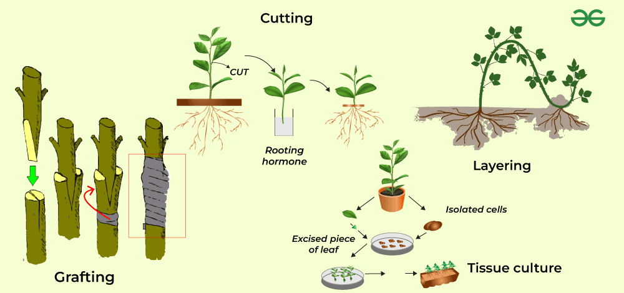

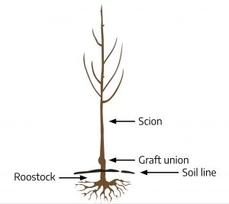

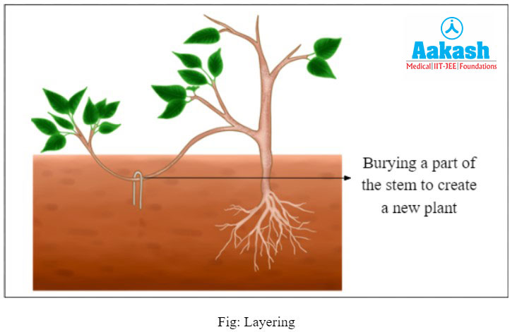

Advantage of vegetative propagation
- Faster growth
- Cloning of desirable traits-
- Can propagate seed less plant like banana, sugarcane, pine apple
- Reliable method.
- Multiple plants from one .
Disadvantage
- No genetic variation
- Limited to certain species
- Spread of diseases.
- Shorter life span.

🌸 Sexual Reproduction in Plants
Sexual reproduction in plants involves the fusion of male and female gametes to produce a new plant. This method leads to genetic variation, making it vital for evolution and adaptation.

🌼 Parts of flower

1.Male Reproductive organ (Stamen)
  - Anther: Swollen tip of the stamen, produces pollen grains which contain male gametes
  - Filament: Stalk that holds the anther
- Female Reproductive Part (Carpel or Pistil)
  - Stigma: Top sticky part, receives pollen
  - Style: The middle part of the Pistil, it is a tube connecting stigma to ovary.
  - Ovary: The swollen part of the bottom, contains ovules (female gametes)
- Sepal: The green, leaf-like part at the base of the flower that protects the bud before it opens.
- Petal: The coloured parts of the flower that attract pollinators like bees and butterflies

- 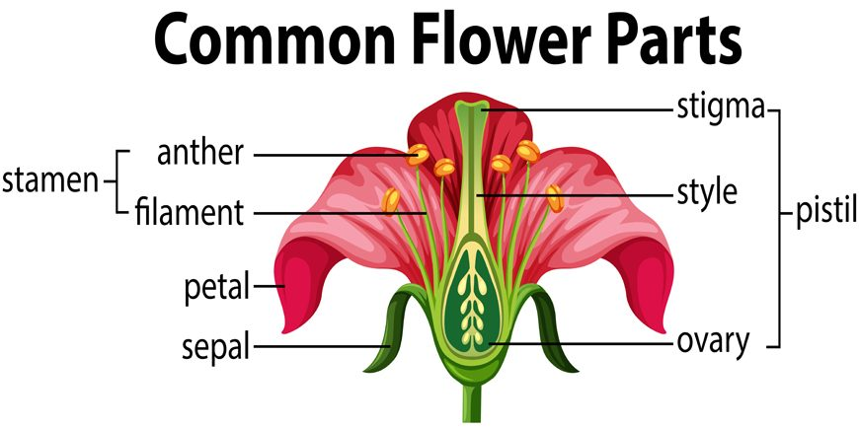
A unisexual flower has either male (stamens only) or female (pistils only) reproductive organs, but not both.
Example: Papaya (male and female flowers separate), watermelon, cucumber

A bisexual flower (also called a “perfect” flower) contains both male (stamens) and female (pistils/carpels) reproductive organs in the same flower.
Example: Hibiscus is a common example, rose etc

🌷 Steps of Sexual Reproduction in Plants
- Pollination
  - Transfer of pollen from anther to stigma
  - Can be:
    - Self-pollination: Same flower or plant
    - Cross-pollination: Different plants
- Fertilization
  - Pollen travels down the style and fuses with the ovule in the ovary
- Seed and Fruit Formation
  - Fertilized ovule becomes a seed
  - Ovary develops into a fruit
- Germination
  - When conditions are right, the seed grows into a new plant

