Worksheet
Ch – A shelter So High
1 . Answer the following:
a)The flat roofs of the houses help to keep the rooms __________ in winter.
b) The people of Ladakh wear warm clothes made of __________.
c) The Pashmina goat lives high up in the __________
d) The fine wool is spun into thread and woven into beautiful __________.
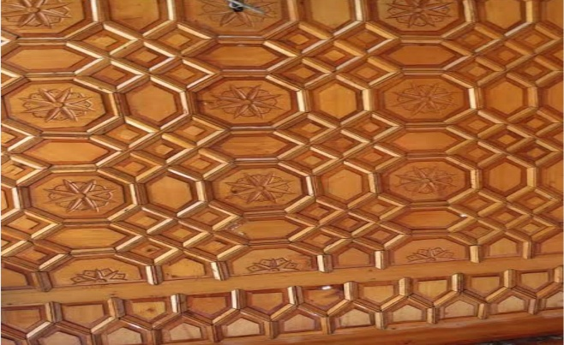
e) Identify and name the given picture also write where you can see this
F) Changpa are the tribe found in ________________ and they keep their animals in _________.
Difference between hot and cold desert. (Any 3)

