EVS CLASS TEST 20/11/2025
Full marks :10
MCQ (1x3=3)
1. Roots does not perform which task for the plant?
a. Absorb the water from the soil.
b. Firmly hold the plant in fixed position.
c. Absorb the oxygen from soil.
d. Absorb minerals from the soil.
2. A farmer notices small unwanted plants growing near his healthy wheat plants. These weeds are taking up sunlight and water. The best way to get rid of this weeds is to-
a. spray them with a lot of water.
b. gently pull them out with hands or use a tool.
c. wait for them to grow bigger.
d. cut them with a knife.
3. A large area of forest was cleared to build a new town. After a few months strong winds started blowing dust and sand away from the site. What has happened to the soil?
a. The soil has become more fertile.
b. The soil is being eroded by the wind.
c. The soil has been wash away by water.
d. The soil has turned into rock.
4. Roots are important to plants. What might happen if plants did not have roots? (1)
5. Mention the importance of prop roots. (2)
6. (i) Identify the type of root. (1)
(ii) Write one characteristic of it.(1)
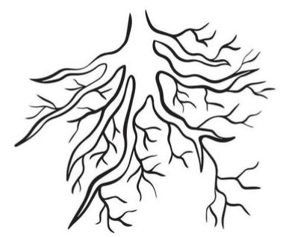
(iii) Write two examples where we can find this type of root. (2)

