VALUE OF WORK

(A) Economic Activities
- These are activities that people do to earn money or livelihood.
- They help people meet their basic needs like food, clothing, and shelter.

Examples:
- A farmer growing crops
- A teacher teaching in a school
- A doctor treating patients
- A shopkeeper selling goods
- A worker in a factory

Features:
- Income is earned
- Can be occupation, job or business
- Helps in economic development of the country

(B) Non-Economic Activities
- These are activities done for love, care, affection, hobby, or social service, not for earning money.
- The aim is personal satisfaction.

Examples:
- A mother cooking for her family
- Students helping in a cleanliness drive
- Playing games as a hobby
- Visiting relatives
- Doing voluntary work without payment

Features:
- No income earned
- Done for emotional satisfaction
- Helps in building relationships and community bonding

2. Types of Activities

(A) Primary Activities
- Activities that involve extraction or use of natural resources.
- These are the first stage of production.

Examples:
- Farming
- Fishing
- Mining
- Forestry
- Dairy farming

(B) Secondary Activities
- These involve processing natural resources to make new products.
- Also called manufacturing or industrial activities.

Examples:
- Making cloth from cotton in factories
- Producing sugar from sugarcane
- Making bread from wheat
- Car manufacturing
- Furniture making

(C) Tertiary Activities
- These are service-based activities that support primary and secondary sectors.
- They help in distribution, communication, and services.

Examples:
- Teachers, doctors, nurses
- Shopkeepers, bankers
- Transport services like buses, trains, couriers
- Communication services like mobile networks, post office

3. Community Participation

What is Community Participation?
- When people of a community come together to perform activities for the benefit of society, it is called community participation.
- It builds cooperation, responsibility, and awareness among citizens

Van Mahotsav is a tree-planting festival celebrated every year in the first week of July in India

Objectives of Van Mahotsav
- To increase awareness about the importance of trees
- To protect the environment
- To control soil erosion and pollution
- To maintain ecological balance

MCQ’S
1.What does the term “money’s worth” refer to?
(a) The physical appearance of money
(b) The monetary value placed on an object
(c) The total amount of money a person has
(d) The exchange rate of money
2. Consider the following statements.
(i) A farmer selling fruits or vegetables in the market is performing a non-economic activity.
(ii) Non-economic activities are done out of feelings like gratitude, love, care and respect.
(iii) Taking care of your grandparents is a non-economic activity.
(iv) A pilot in the Indian Air Force is performing an economic activity.
Which of the above statements are correct?
(a) (i) and (ii)
(b) (iii) and (iv)
(c) (ii), (iii) and (iv)
(d) (i), (iii) and (iv)
3. Assertion (A) Teaching children for free is a non-economic activity.
Reason (R) Non-economic activities do not generate income and are driven by feelings like love and care.
Codes
(a) Both A and R are true and R is the correct explanation of A
(b) Both A and R are true, but R is not the correct explanation of A
(c) A is true, but R is false
(d) A is false, but R is true
4. Assertion (A) Economic activities add value at each stage of transforming something into another form.
Reason (R) Economic activities involve monetary transactions that reflect the value addition process.
Codes
(a) Both A and R are true and R is the correct explanation of A
(b) Both A and R are true, but R is not the correct explanation of A
(c) A is true, but R is false
(d) A is false, but R is true
5.Market is a place where people engage in the exchange of __________ and __________
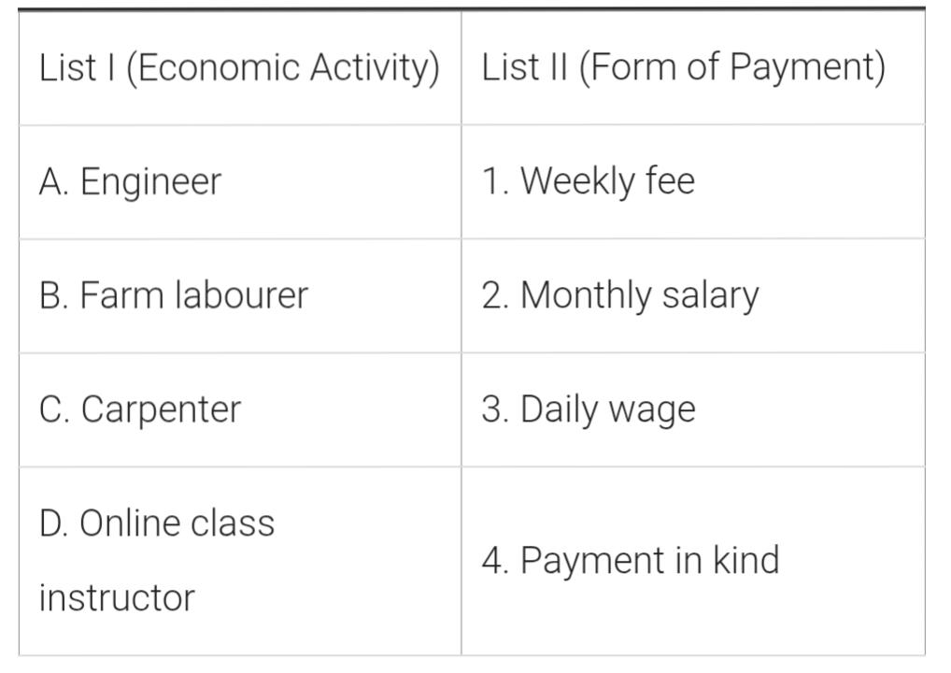
6.

7. Rohit helps his mother in cleaning the house every Sunday. On the same day, his mother works as a tailor and stitches clothes for customers and gets paid.
Which of the following correctly identifies both activities?
A. Rohit – Economic, Mother – Non-economic
B. Rohit – Non-economic, Mother – Economic
C. Both are Economic
D. Both are Non-economic

8.Sita collects waste plastic wrappers during Swachh Bharat Abhiyan as a volunteer. Which statement best explains her work?
A. It is an economic activity because she is cleaning.
B. It is a non-economic activity because it gives her satisfaction, not money.
C. It is a wage-earning activity.
D. It is an activity done to earn fees.

9. During Van Mahotsav, students in a school planted trees in their locality. Which of the following BEST explains the nature of this work?
A. Economic activity because students are doing physical work
B. Non-economic activity because it is for community welfare
C. Wage activity because they receive a fixed payment
D. Salary-based activity
10.Meena goes to a doctor for a health check-up and pays him a certain amount. Which category does the doctor’s income fall under?
A. Wage
B. Fee
C. Payment in kind
D. Non-economic activity

SUBJECTIVE QUESTIONS
1.How does Van Mahotsav unite communities?
2. How do economic activities differ from non-economic ones, using general examples.
3.Rita helps her younger brother with homework every evening, while her father works in a bank and receives a fixed monthly income.
Explain how Rita’s work and her father’s work are different. Use the terms economic and non-economic activities with suitable examples.

4. Why is money considered an important part of economic activities? Explain with examples the difference between wage, salary, and fee.

5. A shopkeeper gives groceries to a worker for repairing the shop shutters instead of giving cash.
Explain why this is called payment in kind, and describe another real-life situation where such payment may take place.

