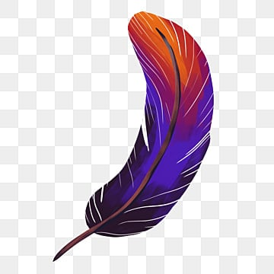
See the picture and write the opposite of it :
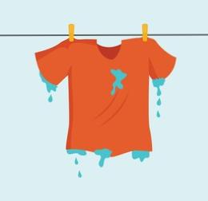
_________________________

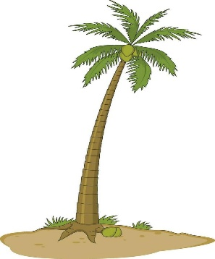
Write the opposite words :
- noisy - ____________________
- awake. - _____________________
- forget - ______________________
- fat - ______________________
- inside - _______________________

