
SATISH CHANDRA MEMORIAL SCHOOL
ACADEMIC SESSION: 2025-26
CASE STUDY & ASSERTION-REASON QUESTION BANK
SEGMENT: NUMBER SYSTEM
CHAPTER 10: EXPONENTS AND POWERS

CASE STUDY

1. A young boy named Aditya visited a wildlife sanctuary on a school field trip. Aditya was excited to see a variety of animals up close. Outside each animal’s enclosure, he noticed that the weight of the animals was written on small boards:
- an Elephant 6350 kg, b) a Giraffe 2646 kg, c) a Tiger 289 kg, d) a Parrot 22.7 g, e) a Sparrow 16 g.

On the basis of above information, answer the following questions.
i) Find the weight of an Elephant in standard form.
ii) Find the total weight of a Parrot and a Sparrow.
iii) If the weight of a Parrot is $\left(a×{10}^{-2}\right)kg$ , then find the value of a.
2. The distance between Earth and Sun is approximately 149,600,000 km. Astronomers often use standard form to express such large numbers in a simpler way.
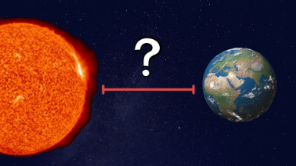
Based on the above information, answer the following questions
i) Write the distance between Earth and Sun in standard form.
ii) The diameter of the Sun is about 1,392,000 km. Write this in standard form.
iii) Convert 0.000056 into standard form.
3. A mathematician is studying the properties of exponents and powers. She writes down the following equation involving a variable$x$. The equations is $2^{x+3}=16$
She wants to solve for $x$ and analyze how changing the equation affects the value of $x$.

Based on the above information, answer the following questions
i) Solve the equation $2^{x+3}=16$
ii) If the equation is changed to $2^{x+3}=64$, what is the new value of $x$?
iii) If the equation $3^{x-2}=27$, solve for $x$.

ASSERTION-REASONING

1. Assertion (A): Multiplying two numbers with the same base adds their exponents.
Reason (R): According to exponent laws, $a^{m} × a^{n} = a^{m+n}.$
2. Assertion (A): Any number raised to a negative exponent results in its reciprocal
Reason (R): $a^{-n} = \frac{1}{a^{n}}, where a ≠ 0$.
3. Assertion (A): Any non-zero number raised to the power of zero is equal to one.
Reason (R): Exponent law states that $a^{0} = 1$ for any non-zero number $a.$
4. Assertion (A): Scientific notation helps in representing very large or very small numbers
Reason (R): Scientific notation expresses numbers as a power of 10 for easier calculation.

