Date: 3.12.25 Science Class Test F.M- 20
Choose the correct option :
1.Assertion (A): Respiration in plants happens all day and night.
Reason (R): Plants need energy continuously for their life processes.
A. Both A and R are true, and R is the correct explanation of A.
B. Both A and R are true, and R is not the correct explanation of A.
C. A is true, R is false.
D. Both A and R are false.

2.Assertion (A): During respiration, carbon dioxide is produced in both plants and animals.
Reason (R): Carbon dioxide is formed when glucose is broken down to release energy.
A. Both A and R are true, and R is the correct explanation of A.
B. Both A and R are true, and R is not the correct explanation of A.
C.A is true, R is false.
D. Both A and R are false.

3. A dog pants (breathes very fast) after running. Why?
A. To take in more carbon dioxide.
B. To cool its body and take in more oxygen.
C. To reduce heartbeat.
D. Only to stop sweating.

4. Why do insects such as ants and cockroaches not use blood to carry oxygen?
A. Their blood is blue.
B. Their heart is very small.
C. Oxygen reaches body cells directly through air tubes.
D. They do not need oxygen.
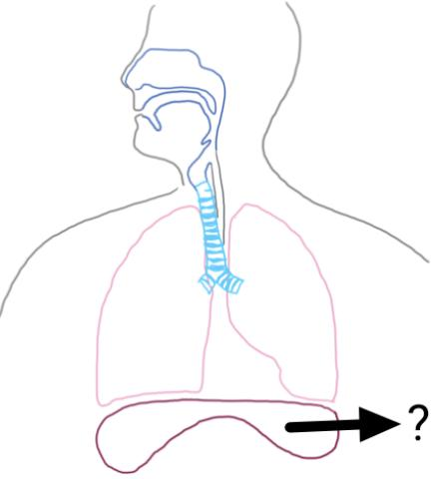
5. In the given diagram, the labelled part helps in-
A. Pumping blood
B. Moving up and down to change chest size
C. Cleaning the air inside lungs
D. Producing mucus

6. On a rainy day, the windows of the car turned foggy from inside when people sat inside and breathed out warm air.
Why did the windows become foggy?
A. Air inside cooled and froze.
B. Water vapour condensed on the cold glass.
C. The cold glass absorbed moisture.
D. Evaporation increased inside the car due to change in temperature.

7. Anita accidentally kept ice cream outside for too long. It turned liquid. What caused the ice cream to melt?
A. Loss of heat from the molecules of water.
B. Absorption of heat from surroundings.
C. Freezing due to change in temperature.
D. Condensation due to contact with cold surface.

8. A student heated a small amount of water in a beaker until it boiled. Suddenly she noticed the temperature of the boiling water stopped rising even though heat was still being supplied.
Why does the temperature not increase?
A. Water stops absorbing heat.
B. All heat is used up in converting water to steam.
C. The thermometer is faulty.
D. Heat escapes too quickly into the air.

9. On a very humid day, Amit hangs wet clothes outside. Even after many hours, the clothes are still damp. What is the main reason for slow drying?
A. Air is too hot.
B. Air already has a lot of water vapour.
C. Clothes are too thick.
D. Breeze is too strong.

10. Solid Ice
↓ (heat)
Liquid Water
↓ (heat)
Steam
Which option correctly matches the order of changes?
A. Freezing → Melting → Evaporation
B. Melting → Evaporation
C. Condensation → Melting
D. Sublimation → Condensation

11. A sealed container experiment showed that a small animal died quickly, but a plant inside the same container survived longer.
What is the MOST accurate reason?
A. Animals do not respire continuously, but plants do.
B. Animals use far less oxygen than plants.
C. Plants produce more oxygen than they use in respiration (in light), so they last longer.
D. Plants do not need oxygen at all if light is present.

12. The true statement about gas exchange in the human lungs is
A. Oxygen moves from blood into the alveoli
B. Carbon dioxide moves from blood into alveoli, and oxygen moves from alveoli into blood
C. Blood releases oxygen into alveoli and absorbs nitrogen
D. Gas exchange happens only when we exhale

13. “Stomata open wider on a rainy day because the plant gets more water from the soil.”
Which statement BEST explains why the student is wrong?
A. Stomata open only when the plant is dry.
B. High humidity on rainy days reduces transpiration, so stomata may actually stay LESS open.
C. Rainwater directly enters the stomata and closes them.
D. Stomata do not respond to humidity at all.
14. “A froglet can live completely on land because it already has legs.”
Which statement BEST explains why this is incorrect?
A. Froglets cannot walk on land at all.
B. Froglets do not have lungs until they become adults.
C. Froglets still have a tail and partly depend on water because their lungs and skin are not fully ready for life on land.
D. Froglets breathe only through gills like tadpoles.

15. A small puddle of water dried quickly in the afternoon sun but stayed much longer in the shade
Which option correctly explains the observations?
A. Water becomes heavier in shade.
B. Sunlight provides more heat, increasing evaporation.
C. Wind avoids shaded areas.
D. Shade pulls water into the ground.

16. Aman boiled water, and when he held a cold metal lid above the steam, large droplets formed on the lid quickly.
A. The lid absorbs water from the air.
B. Steam loses heat quickly and condenses on the cold lid.
C. Steam freezes into droplets.
D. Water inside the lid comes out.

17. Ritu spilled a few drops of spirit on her hand in winter.
Even though the room was warm, her hand felt suddenly very cold and the cold feeling stopped after a few seconds when the liquid completely disappeared.
Which option best explains why her hand felt cold?
A. The spirit absorbed cold air from the surroundings and transferred it to her hand.
B. Spirit has its own natural cooling property, so it lowers skin temperature without needing heat.
C. Spirit evaporated very quickly, using heat energy from Ritu’s skin, which caused the cooling sensation.
D. The skin released moisture when touched by spirit, and that moisture became cold.

18. Two trays of water were kept in a freezer:
Tray A: pure water
Tray B: salted water
After 1 hour, Tray A froze completely but Tray B was still liquid.
What explains this difference?
A. Salt adds heat to water.
B. Salt lowers the freezing point, so it takes longer to freeze.
C. Pure water freezes slower than salt water.
D Only pure water can freeze in a freezer.

19. At a hill station, pasta took much longer to cook even though the water was boiling.
Why did the cooking time increase?
A. Water boils at a higher temperature in hills.
B. Water boils at a lower temperature in hills due to low air pressure.
C. Pot absorbs all the heat.
D. Oxygen freezes at high altitude.

20. The change of state is most important for AWG functioning-
A. Solid → liquid
B. Liquid → gas
C. Gas → liquid
D. Solid → gas

