
SATISH CHANDRA MEMORIAL SCHOOL
ACADEMIC SESSION: 2025-26
CASE STUDY & ASSERTION-REASON QUESTION BANK-CLASS VIII
SEGMENT: DATA HANDLING
CHAPTER 04: DATA HANDLING
CASE STUDY
1. A survey was conducted in a school library to find out the number of books borrowed by students in a week. The data is given below:
Days | Number of books borrowed
Monday | 25
Tuesday | 30
Wednesday | 20
Thursday | 35
Friday | 40
i) What is the total number of books borrowed in the week?
ii) On which day were the maximum number of books borrowed?
iii) What is the average number of books borrowed per day?
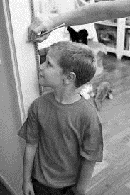
2. During physical education class Samuel’s teacher took the heights (in cm) of 10 students and asked him to not them down, they are: 140, 145, 150, 155, 160, 165, 170, 175, 180, 185.

i) What is the range of the heights?
ii) What is the difference between the second highest height and the second lowest?
iii) What is the average height of the students?
3. Anant went to a car dealership for his project of data handling survey and recorded the number of cars sold in 6 months:
Months | Number of cars sold
January | 10
February | 16
March | 35
April | 26
May | 23
June | 20

i) What is the total number of cars sold in 6 months?
ii) Which month had the highest sales?
iii) What is the difference between the maximum and minimum sales?
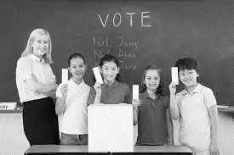
4. In a school election, three candidates are running for the position of head boy/girl: Rahul, Priya, and Ankit. The probability of Rahul winning is 0.4, Priya winning is 0.35, and Ankit winning is 0.25.

i) What is the probability that Rahul or Priya will win?
ii) What is the probability that Priya or Ankit will win?
iii) What is the probability that none of the candidates win? (Assume there is no tie.)
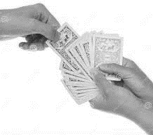
5. While playing cards with a deck of 52 playing cards Ram had to pick one card out of the pack and guess the type of card as asked by his friends.

i) What is the probability that the card Ram picked is a black card?
ii) What is the probability that Ram get a Face card?
iii) What is the probability that Ram picks an Ace card?
ASSERTION – REASONING
1. Assertion(A): A bar graph is used to represent categorical data.
Reason(R):A bar graph uses bars of equal width to show the frequency of each category.
2. Assertion(A): A pie chart is used to compare parts of a whole.
Reason(R):In a pie chart, the area of each sector is not proportional to the quantity it represents.
3. Assertion(A): The range of the data set 10, 20, 30, 40, 50 is 40.
Reason(R):The range is calculated by subtracting the smallest observation from the largest observation.

