Pinocchio Vocabulary Based MCQs
​1. Identify the meaning of the word "queer" as used when the carpenter bought the wood:
A) Heavy and dark
B) Strange or unusual
C) Very expensive
D) Smooth and shiny
​2. Select the tool the carpenter was using when the wood complained of being tickled:
A) A hammer
B) A saw
C) A plane
D) A drill
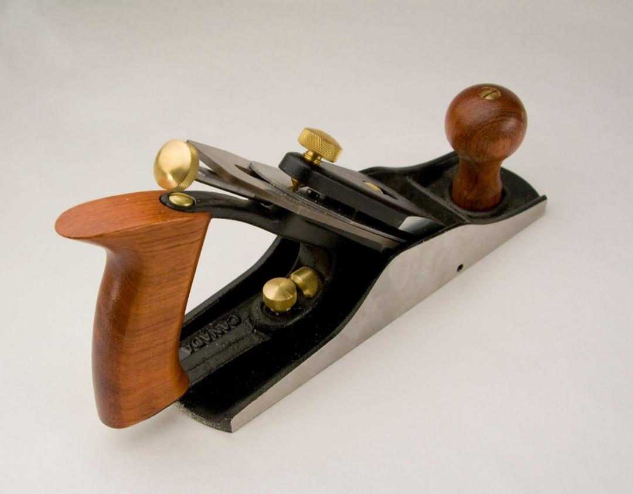

3. Choose the synonym for the word “puzzled” used to describe the old man’s reaction to the voice:
A) Confused
B) Happy
C) Fearful
D) Confident
​4. Define the word “puppet” based on the carpenter’s plan for the wood:
A) A piece of kitchen furniture
B) A movable model of a person
C) A musical instrument
D) A type of gardening tool
​5. Pick the correct meaning of the phrase “took shape” as the boy was being carved:
A) It began to look like a person
B) It broke into many pieces
C) It turned into a circle
D) It became invisible
​6. Name the feeling the carpenter had when he was “amazed” by the moving eyes:
A) Great boredom
B) Extreme surprise
C) Deep sadness
D) Mild anger
​7. Find the best definition for the word “stiff” regarding the puppet’s initial movements:
A) Very fast and quick
B) Firm and difficult to bend
C) Soft and mushy
D) Hot and burning
​8. Recognize the meaning of a “lie,” which caused Pinocchio’s nose to grow:
- A true statement
/B) An intentional falsehood
C) A loud shout
D) A polite greeting
​9. Identify a word that means the same as “finished” in the sentence “he finished making the eyes”:
A) Abandoned
B) Completed
C) Delayed
D) Ruined
​10. Describe the action of “deciding” when Pinocchio promised never to lie again:
A) Forgetting a thought
B) Making up one’s mind
C) Asking for help
D) Refusing to listen

