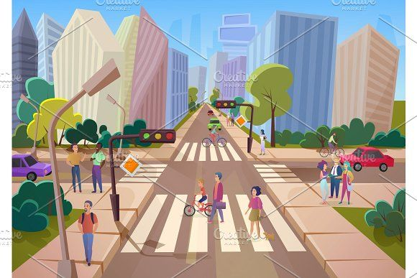
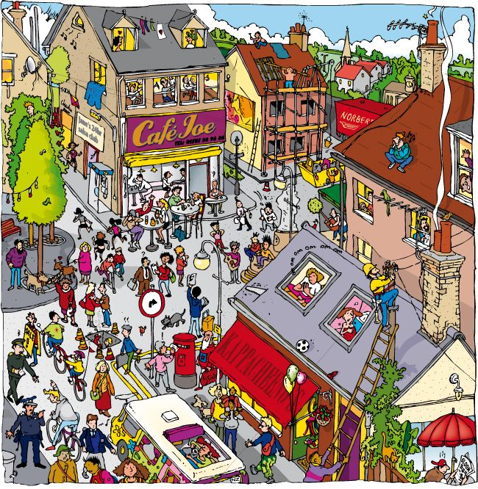

“Sing a Song of People”
Poet: Lois Lenski

Introduction
The poem “Sing a Song of People” describes the lively scene of people moving about in a city. The poet observes people on the streets—walking, talking, rushing, and stopping. Through simple and rhythmic language, the poem celebrates the busy and energetic life of ordinary people.

“Sing a Song of People”
Poet: Lois Lenski

Stanza 1
“Sing a song of people
Walking fast or slow;
People in the city,
Up and down they go.”

Explanation:
The poet asks us to sing about people in the city. Some people walk fast, while others walk slowly. They keep moving up and down the streets. This shows that the city is always busy.
Main idea:
City life is full of movement.

Stanza 2
“People on the side walk,
People on the bus;
People passing, passing,
In back and front of us.”

Explanation:
Here the poet describes people walking on footpaths and travelling in buses. People keep passing by us from all sides—front and back. The city feels crowded and lively.
Main idea:
There are people everywhere in the city.

Stanza 3
“People on the subway
Underneath the ground;
People riding taxis
Round and round and round.”

Explanation:
Some people travel underground in subways. Others travel in taxis that move around the city. This shows different ways people travel in a city.
Main idea:
People use many kinds of transport in city life.

Stanza 4
“People with their hats on,
Going in the doors;
People with umbrellas
When it rains and pours.”

Explanation:
This stanza shows people entering buildings wearing hats. When it rains heavily, people carry umbrellas. The poet shows everyday city scenes.
Main idea:
People adjust themselves according to weather and place.

Stanza 5
“People in tall buildings
And in stores below;
Riding elevators
Up and down they go.”

Explanation:
Some people work or live in tall buildings, while others are in shops below. They use elevators to go up and down.
Main idea:
City life includes tall buildings and busy workplaces.

Stanza 6
“People walking singly,
People in a crowd;
People saying nothing,
People talking loud.”

Explanation:
Some people walk alone, while others move in groups. Some people remain silent, while others talk loudly.
Main idea:
People are different in nature and behaviour.

Stanza 7
“People laughing, smiling,
Grumpy people too;
People who just hurry
And never look at you!”

Explanation:
Some people are happy and smiling, while others are angry or grumpy. Many people are in such a hurry that they do not notice others.
Main idea:
People have different moods and emotions.

Stanza 8
“Sing a song of people
Who like to come and go;
Sing of city people
You see but never know!”

Explanation:
In the last stanza, the poet says that city people come and go every day. We see them daily but do not really know anything about their lives.
Main idea:
City life is crowded, yet people remain strangers.

Theme of the Poem
- Busy city life
- Variety of people
- Different moods and activities
- People as strangers in a crowd

Message of the Poem
The poem shows that city life is full of movement and variety. Though we see many people every day, each person has a different life and story.

Conclusion
“Sing a Song of People” is a joyful poem that celebrates everyday life. It helps students understand how people, though different, together make the city vibrant and alive.

