SATISH CHANDRA MEMORIAL SCHOOL
POST MID EXAMINATION 2025-2026
SUBJECT - SCIENCE
CLASS VII
FM - 40 TIME - 1½ Hrs.

GENERAL INSTRUCTIONS

1. Total 34 Questions in Paper for 40 marks
2. Question no. 1 to 10 Case study-based questions carries 1 mark each. (Section A)
3. Question no. 11 to 30 MCQs carry 1 mark each. (Section B)
4. Question no. 31 to 33 carries 2 marks each. (Section C)
5. Question no. 34 carries 4 marks (Section D)

SECTION A

A. One morning, the school noticed that the bell used during the assembly was not working. The teacher checked the switch and the power supply, but the bell still did not ring. When an electrician examined the device, he found that one of the main connections inside the bell had become loose. After correcting the connection, the bell started functioning normally again.

1. Which effect of electric current is used in an electric bell?
A. Chemical effect B. Heating effect
C. Magnetic effect D. Static effect

2. Why did the bell stop ringing when the wire became loose?
A. The gong was broken B. Current could not flow in the circuit
C. The battery became stronger D. The coil became hot

3. Which part inside the bell strikes the gong?
A. Switch B. Armature C. Battery D. Electromagnet

4. What happens to the electromagnet when current flows through it?
A. It melts B. It becomes a permanent magnet
C. It gets demagnetised D. It becomes magnetised

5. How does the bell produce sound repeatedly?
A. By rotating a fan inside B. By vibrating the permanent magnet
C. By repeatedly making and breaking the circuit D. By heating the gong

B. In a school garden, students observed different kinds of plants growing in separate plots. Some plants were tall, while others were small and spread across the soil. During their regular visit, the students noticed new plants appearing in various parts of the garden. These new plants were growing either near the older plants or in completely different spots. The teacher asked the students to carefully observe how these young plants had developed and note down the possible reasons behind the appearance of so many new plants in the garden.

6. The appearance of new plants in the garden is mainly related to which process in plants?
A. Photosynthesis B. Respiration C. Reproduction D. Transpiration

7. The new plants appearing near the older ones most likely developed due to which of the following?
A. Movement of nutrients within soil B. Formation of new plants from existing plant parts
C. Increase in soil moisture D. Change in leaf structure

8. The presence of young plants at far-off locations in the garden suggests which biological phenomenon?
A. Transport of minerals B. Seasonal variation in plant growth
C. Natural movement of reproductive units D. Change in temperature

9. In the absence of seed formation, which of the following plant structures can independently give rise to new plants depending on species?
A. Roots only B. Stems only C. Leaves only D. Multiple plant parts

10. The students were asked to identify how new plants formed. Which step would help them understand the process correctly?
A. Observing plant height B. Checking the origin of young plants
C. Measuring leaf size D. Counting flowers

SECTION B

Table: Temperature of a metal rod heated at one end. (Read questions from 11 to 14 and answer it properly)
Distance from heated end (cm) | Temperature (°C)
0 | 90
2 | 76
4 | 63
6 | 55
8 | 45

11.What does the decrease in temperature with distance show?
A. Heat flows from colder end to hotter end
B. Heat flows from hotter end to colder end
C. Temperature of metal remains constant everywhere
D. Metal does not conduct heat

12. Which process of heat transfer is shown in this activity?
A. Convection B. Radiation
C. Conduction D. Insulation

13. If the rod was made of wood instead of metal, what would happen to temperature readings?
A. Temperatures would remain the same B. All temperatures would become zero
C. Temperature rise would be very slow or negligible D. Temperature would be higher than metal
14. Why is the temperature highest at 0 cm?
A. Heat source is far away from this point B. Heat source is closest to this point
C. Metal cools at this point D. Metal reflects heat here

15. A car increases its speed from 20 km/h to 60 km/h in 2 hours. Which relation is correct for its average speed?
A. More than 60 km/h B. Less than 20 km/h
C. Between 20 km/h and 60 km/h D. Exactly 40 km/h

16. A vehicle moves in a circular track with constant speed. Which is TRUE?
A. Speed and direction both remain constant B. Speed is constant but velocity changes
C. Velocity is constant but speed changes D. Both speed and velocity will change

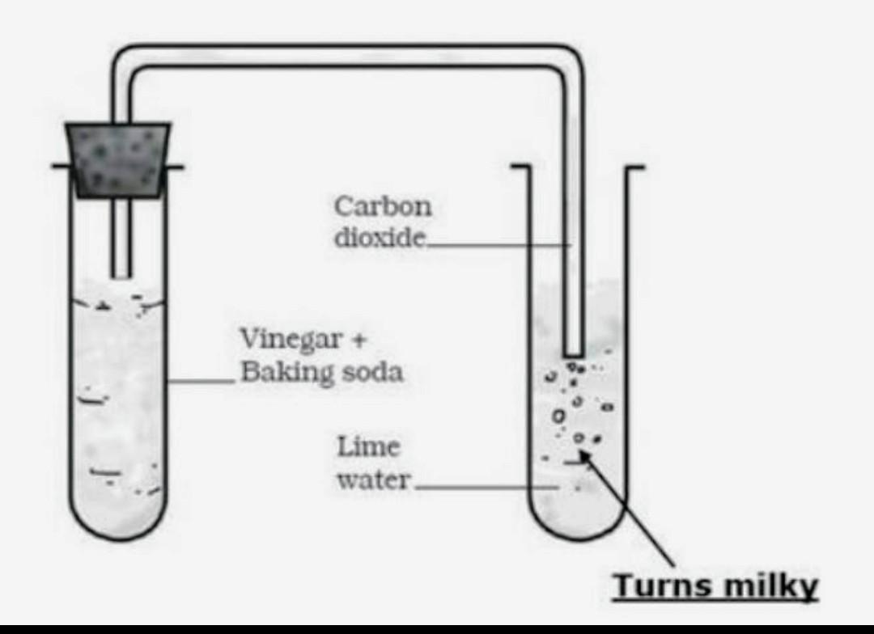
Diagram based questions. Observe the diagram given besides, answer the following questions from 17 to 19

17. What is the main purpose of passing the gas into lime water in this experiment?

A. To increase the temperature of lime water
B. To test the presence of carbon dioxide
C. To dissolve lime water completely
D. To remove impurities from vinegar

18. Which of the following correctly identifies the type of change occurring when vinegar reacts with baking soda?
A. Physical change only B. Reversible change
C. Chemical change producing a gas. D. No change occurs

19. In the setup, why is a delivery tube used?
A. To cool down the gas B. To allow the gas to escape outside
C. To transfer the produced gas into lime water D. To mix vinegar and baking soda

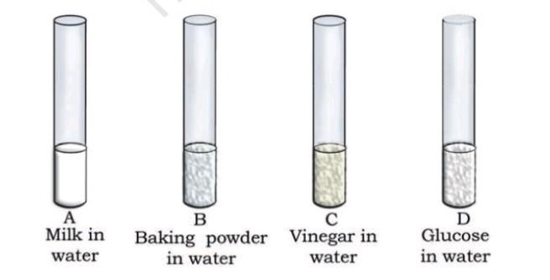
20. Look at the figure, which shows different solutions in test tube A, B, C and D. What colour change is expected when red litmus is only provided to you.

A. A- No change, B- Blue, C- No change, D- No change
B. A- No change, B- Red, C- No change, D- No change
C. A- No change, B- No change, C- No change, D- No change
D. A- Yellow, B- Blue, C- No change, D- Pink

21. A car travels a distance of 192 km in 3 hours. What is its average speed in km/h?
A. 64 Km/h. B. 54 Km/h. C. 44 Km/h. D. 34 Km/h.

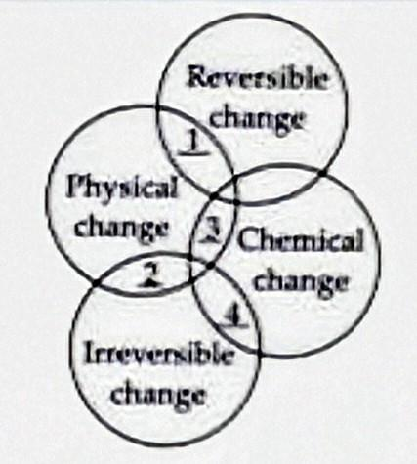
22. Identify 1, 2, 3 and 4 from the given Venn diagram.
 | 1 | 2 | 3 | 4
A. | Falling of trees | Occurrence of rainbow | Growth of plant | Tearing paper into pieces
B. | Knitting sweater with wool | Milk to curd conversion | Making rice puddings | Dissolving sugar in water
C. | Expansion of mercury in thermometer | Breaking of glass | Burning of LPG | Boiling of egg
D. | Filling of water bottle | Melting of ice | Burning of paper | Boiling of water

23. Convert 100°C to K
A. 373.15 K. B. 273.15 K. C. 173.15 K. D. 73.15 k

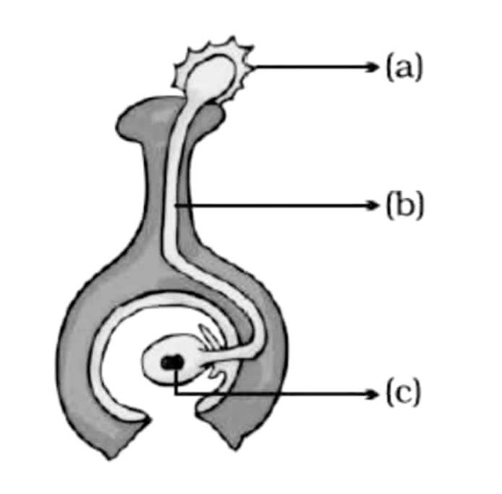
24. Identify a, b and c

A. a- Pollen grain, b- Pollen tube, c- Zygote

B. a- Pollen tube, b- Pollen grain, c- Zygote

C. a- Stigma, b- Pollen tube, c- Style

D. a- Zygote/ egg, b- Style, c- Pollen grain

25. Which of the following shows the correct sequence of events during fertilization in a bisexual flower?
A. Pollen tube formation → Pollination → Fusion of gametes → Pollen grain germination
B. Pollination → Pollen grain germination → Pollen tube formation → Fusion of gametes
C. Fusion of gametes → Pollination → Pollen tube formation → Pollen grain germination
D. Pollination → Fusion of gametes → Pollen grain germination → Pollen tube formation

26.Which of the following devices works solely on the heating effect of electric current?
A. Electric bell. B. Fuse C. Electric iron. D. Both B and C

27. Assertion (A): Burning of magnesium ribbon produces a white ash that cannot be converted back to magnesium metal.
Reason (R): A chemical change results in formation of substances whose properties remain similar to the original substance.
A. Both A and R are true, and R explains A
B. Both A and R are true, but R does NOT explain A
C. A is true, R is false
D. A is false, R is true

28. Assertion (A): Heating blue copper sulphate crystals to remove water of crystallisation is a reversible change.
Reason (R): Adding water back to the white powder restores the blue colour, showing that no new substance was formed during heating.
A. Both A and R are true, and R explains A
B. Both A and R are true, but R does NOT explain A
C. A is true, R is false
D. A is false, R is true

29. Assertion (A): The stomach releases hydrochloric acid.
Reason (R): Hydrochloric acid kills bacteria entering with food.
A. Both true, R explains A
B. Both true, R does not explain A
C. A true, R false
D. A false, R true

30. Assertion (A): In a thermometer, mercury rises when temperature increases.
Reason (R): Mercury contracts on heating and expands on cooling.
A. A and R both true, R explains A
B. A and R both true, R doesn’t explain A
C. A true, R false
D. A false, R true

SECTION C

31. Draw the simple circuit, by using symbols, that is required to make electromagnet. Based on your circuit, mention the direction of formation of the North and South pole when electricity will pass through it along with proper justification. (1+1)

32. Write at least one important characteristic each for the flowers that will only undergo for
i. Self-pollination. ii. Cross pollination. (1+1)

33. For making Pizza a organism, which comes under the category of Fungi, is used in making the dough fluffy, Identify the type of reproduction that takes place in that organism and explain the process of how a new organism is formed by using diagrams step by step. (½+1½)

SECTION D

34. When substance 'X' is mixed with water it produces substance 'Y' along with the formation of heat. When substance Y is tested with red litmus it turns into blue. Substance 'Y' in the test tube is then further being reacted with exhale air of human beings then the whole solution turned into milky solution 'Z'. At the last solution 'Z' is further heated to get back substance 'X' along the gas that human beings release after the respiration process.

A. Write a chemical reaction in which substance 'Y’ is formed and along with the chemical reaction identify X and Y. (1)
B. Write a chemical reaction in which Substance 'Z' is formed and identify Z and the exhaled air that is released after the respiration process. (1)
C. Identify the nature of substance Y. And write the chemical reaction in which we can get back substance 'X' along with the gas that is produced after the respiration process as well as mention its type of chemical reaction. (½+1+½)

