IMPORTANT POINTS TO REMEMBER
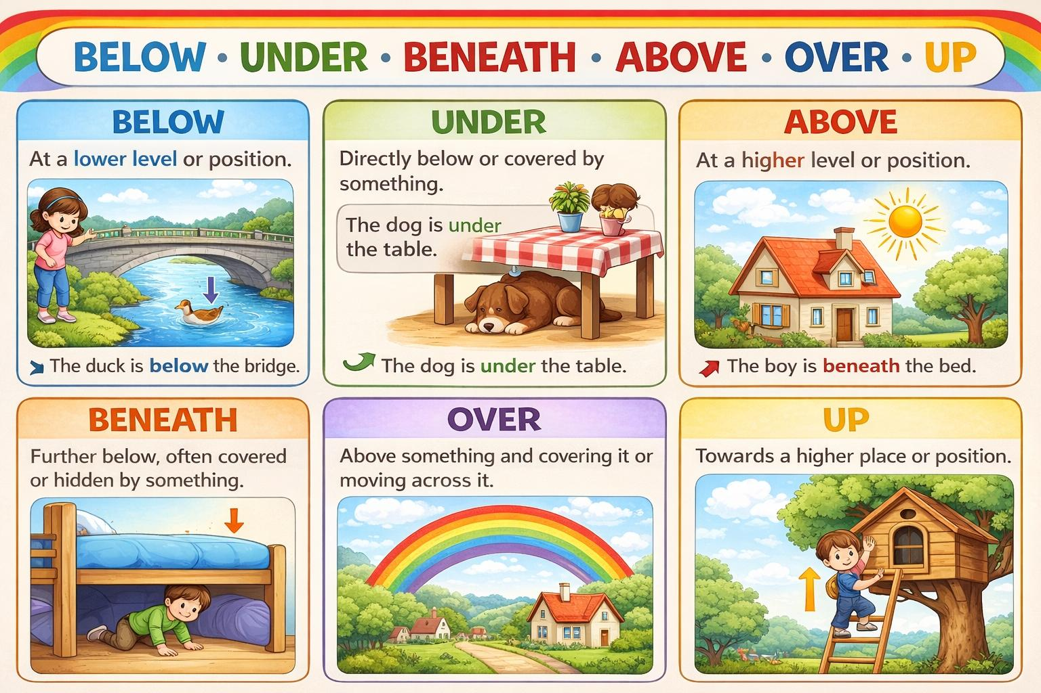

Below

Below means at a lower level or position than something.
Example: The river flows below the bridge.

Under

Under means directly below something and often covered by it.
Example: The cat is sleeping under the table.

Beneath
Beneath means under something usually closer and hidden.
Example: The ball is beneath the bed.

Above
Above means at a higher level or position than something.
Example:The sun is above the house.

Over
Over means higher than something and sometimes moving across it.
Example: A bird is flying over the tree.

Up
Up means towards a higher place or position.
Example: The boy climbed up the ladder.

