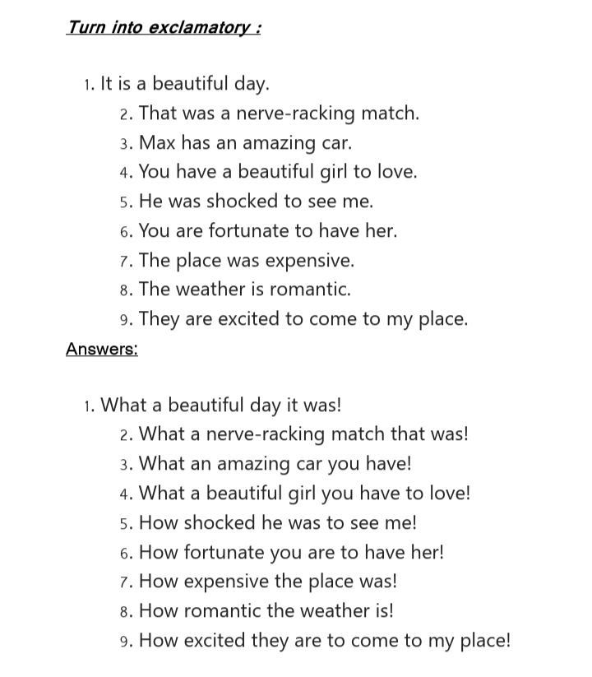
To transform an Assertive sentence (a statement) into an Exclamatory sentence (expressing strong emotion), you follow a few specific grammatical patterns.
Here are the primary rules and structures:
—
1. The "How" and "What" Rule
This is the most common transformation.
• Use "What" if the assertive sentence has a noun (usually preceded by 'a' or 'an').
• Use "How" if there is only an adjective or adverb (no noun).
Structure:
• What + (a/an) + Adjective + Noun + Subject + Verb!
• How + Adjective/Adverb + Subject + Verb!
Examples:
• Assertive: It is a very beautiful bird.
• Exclamatory: What a beautiful bird it is!
• Assertive: The flower is very lovely.
• Exclamatory: How lovely the flower is!
—
2. Replacing "Very" or "Great"
Words like very, great, extremely, or indeed are removed and replaced by "How" or "What" at the beginning of the sentence.
Examples:
• Assertive: He is a great fool.
• Exclamatory: What a fool he is!
• Assertive: It is extremely hot today.
• Exclamatory: How hot it is today!
—
3. Transforming "I wish" Sentences
If an assertive sentence begins with "I wish," it is replaced by exclamatory words like If, Had, Would that, or O that.
Examples:
• Assertive: I wish I were a king.
• Exclamatory: If I were a king! (or Would that I were a king!)
• Assertive: I wish I had the wings of a bird.
• Exclamatory: Had I the wings of a bird!
—
4. Replacing Expressions of Joy, Sorrow, or Wonder
If the sentence describes a specific emotion using phrases like "It is a matter of joy/sorrow," replace that phrase with an interjection.
• "It is a matter of joy that..." → Hurrah!
• "It is a matter of sorrow that..." → Alas!
• "It is a matter of shame/disgrace that..." → Fie! / Shame!
Examples:
• Assertive: It is a matter of joy that we have won the match.
• Exclamatory: Hurrah! We have won the match.
• Assertive: It is very sad that he failed.
• Exclamatory: Alas! He failed.
—
Summary Checklist for Transformation:
1. Move the verb to the end: In many exclamatory sentences, the verb moves to the very end of the sentence.
2. Remove "Very": Never include the word "very" or "great" in the exclamatory version.
3. The Exclamation Mark: Always end the sentence with an exclamation mark (!).
4. Articles: If the assertive sentence has 'a/an', the exclamatory sentence usually starts with "What a/an".
—

