No place for us
5. Arjun’s father is a computer scientist. He gets an offer to work for a big technology company in the United States. The whole family decides to move from India to America for a few years so Arjun can also attend a school there.
A)Is this move an example of internal or international migration?
This is international migration
- Emigration: Leaving your own country to live in another.
- Immigration: Entering a new country to settle there.
B) Name one thing Arjun might find difficult in his new school.
Ans by own
6.Observe the given picture and answer the following questions below

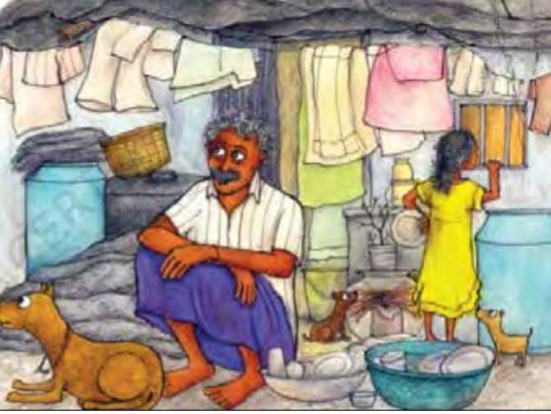
- Mention the skills from Khedi village were useful for Jatryabhai to earn money in Mumbai?
- List two things that Jatryabhai had to pay for in the city that were free in his village.
- What work did young Sidya do to help his father in Mumbai?

