Q. Explain the construction and working of a clinical thermometer.
👉 Construction:
A clinical thermometer is made of a thin glass tube. At one end, it has a bulb filled with mercury. From the bulb starts a very narrow tube called a capillary tube. Just above the bulb, there is a kink (constriction) in the capillary tube. Along the glass tube, there is a temperature scale, usually marked in degrees Celsius (°C), generally from 35°C to 42°C, which is suitable for measuring human body temperature.
Working:
When the bulb of the thermometer is placed under the tongue or in the armpit, the mercury inside the bulb absorbs heat from the body. As mercury gets heated, it expands and rises up in the capillary tube. The mercury level stops rising when it reaches the body temperature.
The kink prevents the mercury from falling back immediately when the thermometer is removed, allowing the reading to be noted correctly. After taking the reading, the thermometer is gently shaken so that the mercury returns to the bulb and the thermometer is ready for use again.
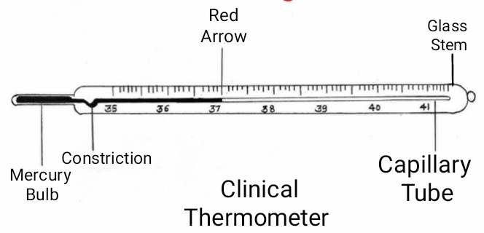

Case study –
Priya was feeling unwell. Her mother suspected that she might have a fever. She took out a clinical thermometer from the medicine box. Before using it, she shook the thermometer properly and placed it under Priya’s tongue for about one minute. After removing it, she read the temperature carefully and found it to be 38°C. She cleaned the thermometer with antiseptic solution and kept it safely in its case.
Questions-
- Priya’s mother shook the thermometer before using it. Why?
- What does the reading of 38°C indicate about Priya’s health?
- A clinical thermometer suitable for measuring body temperature but not for measuring the temperature of boiling water. Why?
- What would happen if the thermometer was not cleaned after use?

