EVS Class Test
16/1/2026 FM-10
1. Tamil Nadu is a state famous for which saree?
(a) Pochampalli (b) Taant (c) Kanjeevaram (d) Moirang Phee
2. Silkworms mainly feed on
(a) grass (b) neem leaves
(c) mulberry leaves
(d) mango leaves
3. Dye is a substance which gives ________ to a fibre.
a) colour b) whiteness
c) darkness. d) shine
4. Mention 2 reasons for promoting Pochampalli handloom sarees. (2)
5. If your family had a special craft like making toys or cooking a special dish. Would you want to learn it? Why or why not? How would you help your parents?(2)
6. Observe the picture and answer: (3).
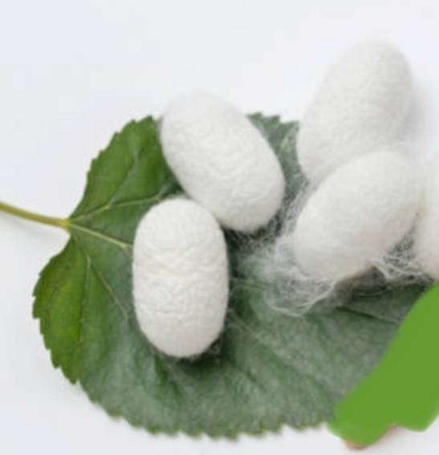
- Name the thing that you are observing.
- Write the importance of this stage in the life cycle of silkworm

