CLASS TEST
Date: 21.1.26 F.M- 15 Chapter- BEYOND EARTH

- Multiple choice questions – (3 marks)

1. Choose the incorrect statement.
a. The Big Dipper is also known as Saptarishi.
b. The Big Dipper don’t have a Pole star so it doesn’t help in navigation.
c. The Big Dipper is a constellation which is visible from both the hemispheres of the Earth.
d. The Big Dipper is a big spoon shaped pattern of stars.

2. Assertion (A): Asteroids usually have irregular shapes.
Reason (R): Asteroids form a long tail when they come near to the sun.
a. Both A and R are true and R is the correct explanation of A
b. Both A and R are true but R is not the correct explanation of A
c. A is true but R is false
d. A is false but R is true

3. The shape of the ______ galaxy shown in the picture is best described as:
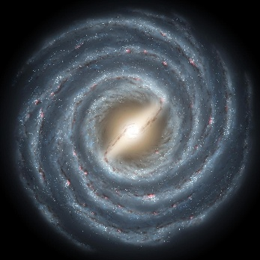
a. Milky way, Elliptical
b. Andromeda, Irregular
c. Milky way, Spiral
d. Magellanic cloud, Circular

- Answer the following subjective questions- ( 7 marks)

4.Two students debate whether Earth can be called a satellite since it moves around the Sun, while the Moon moves around Earth.
(a) On what basis can Earth be considered a satellite? (1)
(b) What makes the Moon different from planets like Earth? (1)
5. A rocky object from space passes through three different stages while coming close to the Earth.
With the help of a neat labelled diagram of the following objects, explain what happens to the object in each stage. (3)
- the object in space,
- the object burning in Earth’s atmosphere, and
- the object reaching Earth’s surface.
6. A student notices that Mercury has no atmosphere, while Venus has a very thick atmosphere, yet both are inner planets.
(a) How does the presence or absence of an atmosphere affect a planet’s temperature? (1)
(b) Mercury is the closest planet to the Sun, yet it is not the hottest planet. Why? (1)

- Read the given case and answer the following questions- (5 marks)
On a clear winter night, a group of astronomy students from Horizon High School gathered on the school rooftop for a sky-watching session. Their teacher, Dr. Meera Rao, pointed toward the eastern sky where a bright and familiar pattern of stars dominated the horizon. This was the Great Hunter, one of the most recognizable constellations in the night sky.

7. Write the name of the constellation and one of its famous star that the students have observed in the night sky. (1+1)

8. Draw the constellation on the western side of the Great Hunter with the brightest star in it. (3)

