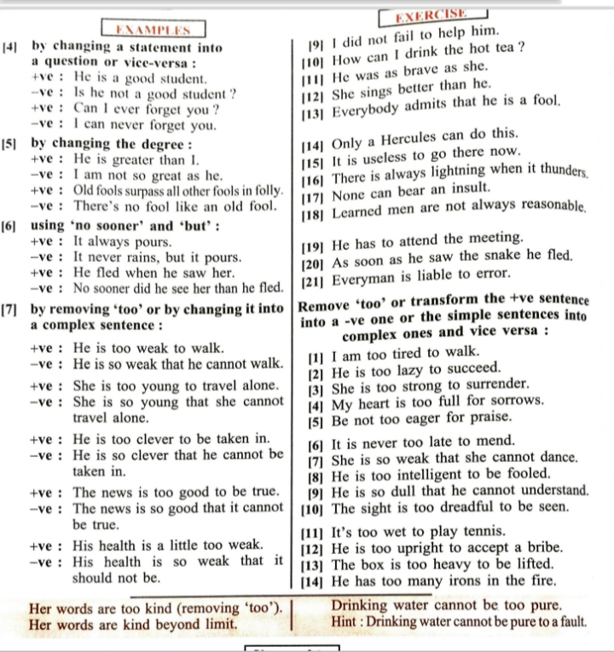
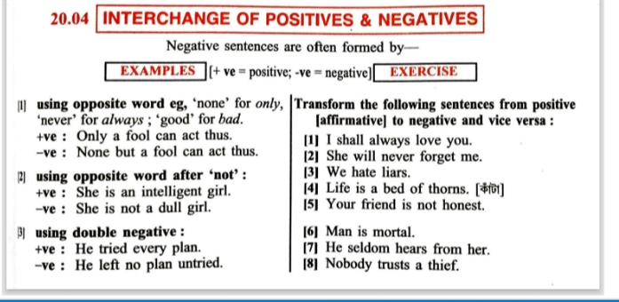
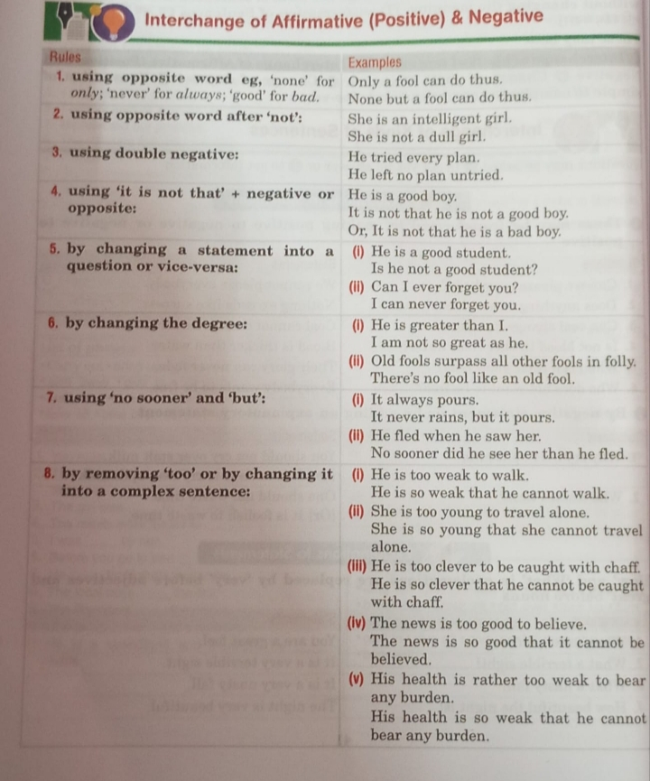
Negative to Positive, Positive to Negative

1. Is he a poor person?
2. Wasn't he very kind?
3. Shall I ever forget those memorable moments?
4. Isn't this a very interesting book?
5. Haven't I done my task?
6. What can be better than a relaxed life?
7. Is this the kind of dress to wear in the party?
8. Does anyone trust him?
9. Can you not solve the sum?
10. Doesn't she like vanilla flavour?
11. Who can beat him in boxing?
12. What though if you fail in the interview?
13. Do you ever play basketball?

Answer key

1. He is not a poor person.
2. He is very kind.
3. I shall never forget those memorable moments.
4. This is a very interesting book.
5. I have done my task.
6. Nothing can be better than a relaxed life.
7. This is not the kind of dress to wear in the party.
8. Nobody trusts him.
9. I can solve the sum.
10. She likes vanilla flavour.
11. No one can beat him in boxing.
12. It does not matter if you fail in the interview.
13. You never play basketball.
Transform the following Affirmative Sentences into Negative Sentences :-
1. Hardly had Ram seen me when he called
me.
2. It is unlikely that Rakesh will help you.
3. Only good girls got good marks.
4. My shirt is loose.
5. As soon as the clock struck ten, we went to sleep.
6. As soon as he came, it began to rain.
7. He is too miser to spend any money.
8. He loves all.
9. Iron is more useful than gold.
10. He found him dishonest.
Answers :
1. Negative – No sooner had Ram seen me than he called me.
2. Negative – It is not like that Rakesh will help you.
3. Negative – None but good girls got good marks.
4. Negative – My shirt is not tight.
5. Negative – No sooner did the clock strike ten than we went back to sleep.
6. Negative – No sooner did he come than it began to rain.
7. Negative – He is so miser that he can not spend any money.
8. Negative – He does not hate all.
Or
Negative – He does not fail to love all.
9. Negative – Gold is not so useful as iron.
10. Negative – He did not find him honest.
Or
Negative – He did not fail to find him dishonest.

