Detection of low quality cloves in cloves
Materials Required- glass beaker, cloves, water
Method- 1.Take some water in a beaker. 2.Put cloves.
Observation- Some cloves may float, some may settle down at the bottom.
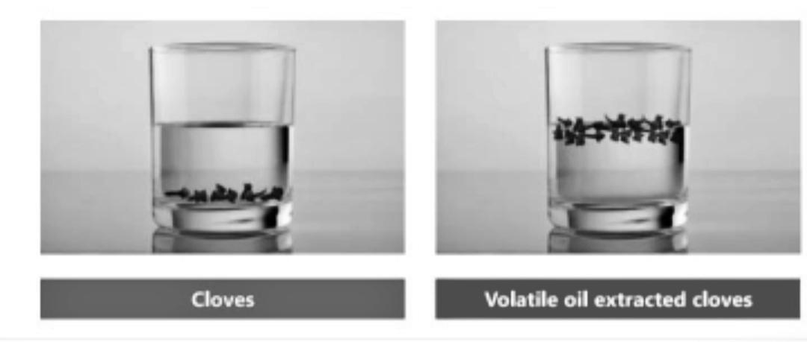
Inference- Genuine cloves will settle down at the bottom. Low quality cloves will float on the surface.
Differentiation of common salt and iodised salt
Materials Required- Potato, salt, lemon juice.
Method- 1. Cut a piece of potato, add salt. Wait for a minute.
2. Add two drops of lemon juice.
Observation- Blue colour may develop on the potato.
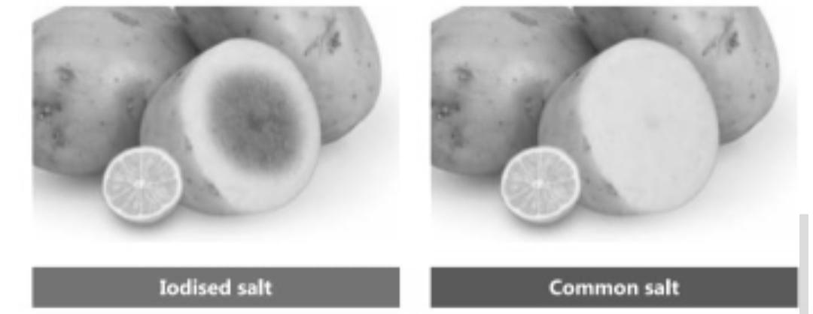
Inference- If it is iodised salt, blue colour may develop. If it common salt, there will be no colour.

