A Seed Tells A Farmer’s Story
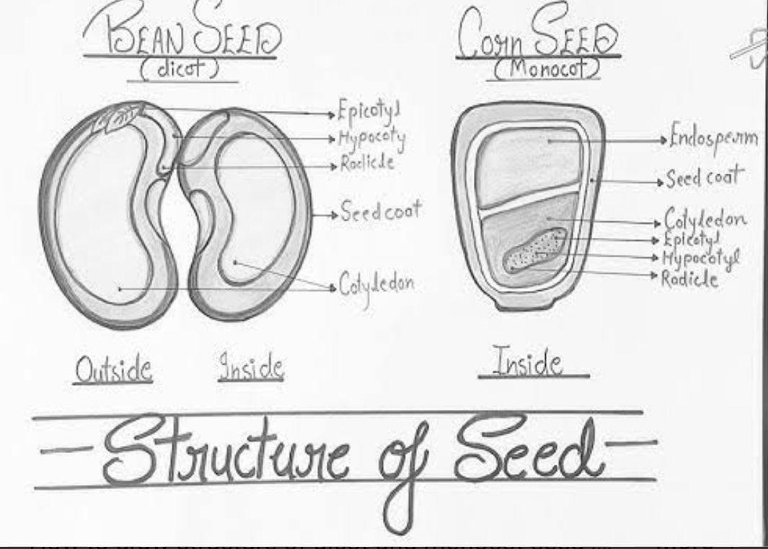

Monocot (monocotyledon) – It is a flowering plant whose seed contains one cotyledon (seed leaf).

Dicot (dicotyledonous)- It is a flowering plant whose seed contains two cotyledons (seed leaves).

Agriculture – It is the practice of cultivating soil, growing crops for food, fiber, and other useful products.

Traditional farming – It is a method of agriculture that uses age-old techniques, simple tools, and natural inputs with little use of modern technology.

Organic farming- It is a method of agriculture that uses natural inputs and processes to grow crops and raise animals without synthetic chemicals or genetically modified organisms.

Modern farming – It is a method of agriculture that uses advanced technology, machinery, improved seeds, and chemical inputs to increase crop production.

